**ĐỀ THI HỌC KỲ II**

**Question 1: Tìm từ khác loại**

1. A. chicken B. noodle C. camera D. rice

2. A. family B. shoes C. skirt D. jeans

3. A. elephant B. favourite C. giraffe D. tiger

4. A. bakery B. school C. hotel D. breakfast

**Question 2: Nhìn tranh và hoàn thành các từ còn thiếu**

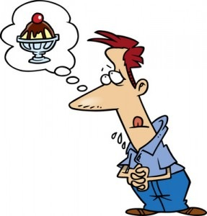

1. h_ _ _r_ 2. _o_p_ _ _l 3. m_s_ _i_ _

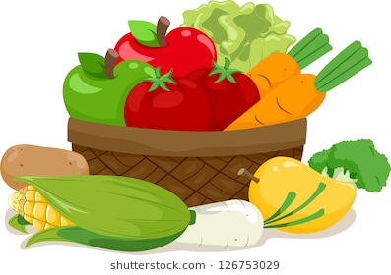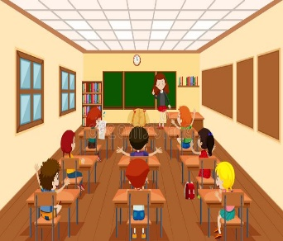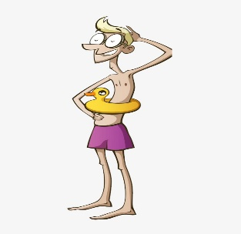

4. _e_ _ta_le 5. cl_ _ _r_ _ _ 6. _h_ _

**Question 3: Điền YES vào câu đúng hoặc No vào câu sai.**

Dear Phong, I’m Jack. Yesterday was fun and relaxing. I got up late. In the morning, I cleaned my room. In the afternoon, I watered the flowers in the garden. Then I did my homework. In the evening, I chatted online with my friend Nam. We talked about our favorite films. What did you do yesterday?

**Jack: YES or NO?**

1. Jack got up early. …………

2. In the morning, he cleaned the living room. ………………

3. In the afternoon, he worked in the garden. ………………

4. In the evening, he chatted online with his friend Mai. ………………

**Question 4: Điền vào đoạn văn dựa vào các từ cho sẵn (có 2 từ không dùng)**

***photos a hospital car picnic swimming***

This is my father. He is a doctor. He works in a (1) ______________. He is always busy. On the weekends, we often have a (2) ______________ in the park. We usually go there by car. I like (3) ______________ very much, so my father sometimes drives me to the beach. We often take some (4) ______________.

**Question 5: Sắp xếp các từ sau thành câu hoàn chỉnh**

1. I/ like/ monkeys/ don't.

______________________________________________.

2. you/ want/ some/ Do/ a/ cakes?

______________________________________________.

3. every day/ I/ brush/ teeth/ my.

______________________________________________.

4. your/ What/ favorite/ is/ color/?

______________________________________________.

**ĐÁP ÁN**

**Question 1:**

|  |  |  |  |
| --- | --- | --- | --- |
| 1. C | 2. A | 3. B | 4. D |

**Question 2:**

|  |  |  |
| --- | --- | --- |
| 1. hungry | 2. hospital | 3. musician |
| 4. vegetable | 5. classroom | 6. thin |

**Question 3:**

|  |  |
| --- | --- |
| 1. YES | 2. NO |
| 3. YES | 4. NO |

**Question 4:**

|  |  |
| --- | --- |
| 1. hospital | 2. picnic |
| 3. swimming | 4. photos |

**Question 5:**

1. I don’t like monkeys.

2. Do you want some cakes?

3. I brush my teeth every day.

4. What is your favourite colour?