**UNIT 12: WHAT DOES YOUR FATHER DO?**

**A. VOCABULARY**

|  |  |
| --- | --- |
| Clerk | Nhân viên |
| Doctor | Bác sĩ |
| Farmer | Nông dân |
| Teacher | Giáo viên |
| Driver | Tài xế |
| Factory | Nhà máy |
| Farm | Nông trại |
| Hospital | Bệnh viện |
| Field | Cánh đồng |
| Nurse | Y tá |
| Office | Cơ quan |
| Student | Học sinh |
| Uncle | Bác |
| Worker | Công nhân |
| Musician | Nhạc sĩ |
| Writer | Nhà văn |
| Engineer | Kỹ sư |
| Singer | Ca sĩ |
| Pupil | Học sinh |
| Pilot | Phi công |
| Postman | Người đưa thư |
| Future | Tương lai |
| Piano | Đàn pi a nô |
| Company | Công ty |
| Same | Giống |
| Different | Khác |
| Housewife | Người nội trợ |

**B. GRAMMAR**

**1. Hỏi đáp về nghề nghiệp**

Khi muốn hỏi ai đó làm nghề gì, ta dùng cấu trúc:

What + do/ does + S + do?

Vởi chủ ngữ là người đối diện (you), câu hỏi sẽ có dạng: What do you do?

Nếu muốn hỏi nghề nghiệp của 1 người khác, ta hỏi: What does + he/ she/ tên người + do?

Để trả lời ta dùng cấu trúc đơn giản: S + be (am/ is/ are) + a/an + nghề nghiệp.

VD:

- What do you do?

I am a pupil.

- What does your mother do?

She is a nurse.

**2. Hỏi đáp ai đó làm việc ở đâu**

Để hỏi ai làm việc ở đâu ta có cấu trúc:

Where do/ does + S + work?

Cách chia do/ does vẫn tương tự như trên. Ta dùng do với các chủ ngữ I, you, we, they và danh từ số nhiều. Ta dùng does với các chủ ngữ she, he, it và các danh từ số ít.

Trả lời: S + work(s) + in/ on/ at + địa điểm

VD:

Where does he work?

He works in a hospital.

**C. TASK**

***Exercise 1: Điền nghề nghiệp thích hợp vào chỗ trống và khoanh tròn “a” hoặc “an”***

1. A/ an _____________ sings songs.

2. A/ an _____________ works in the field.

3. A/ an _____________ delivers letters.

4. A/ an _____________ teaches students.

5. A/ an _____________ works in the hospital with a nurse.

6. A/ an _____________ drives a car.

7. A/ an _____________ works in a factory.

8. A/ an _____________ designs building.

**ĐÁP ÁN**

|  |  |  |  |
| --- | --- | --- | --- |
| 1. A singer | 2. A farmer | 3. A postman | 4. A teacher |
| 5. A doctor | 6. A driver | 7. A worker | 8. An engineer |

***Exercise 2: Sắp xếp các chữ cái để được từ đúng***

1. EERGINE __________________

2. HOWIUSEFE __________________

3. LOTPI __________________

4. CTOFARY __________________

5. YMOCPAN __________________

6. RTFUUE __________________

7. EIFLD __________________

8. FFRENTDIE __________________

**ĐÁP ÁN**

|  |  |  |  |
| --- | --- | --- | --- |
| 1. engineer | 2. housewife | 3. pilot | 4. factory |
| 5. company | 6. future | 7. field | 8. different |

***Exercise 3: Chọn từ khác loại***

1. A. what B. do C. does D. did

2. A. same B. the C. a D. an

3. A. doctor B. nurse C. hospital D. dentist

4. A. farmer B. clerk C. police D. piano

**ĐÁP ÁN**

|  |  |  |  |
| --- | --- | --- | --- |
| 1. A | 2. A | 3. C | 4. D |

***Exercise 4: Điền từ thích hợp vào đoạn văn***

|  |
| --- |
| **In and years name**  **are an my housewife** |

I am Ping. There (1) ___________ four people in my family: my father, my mother, my sister (2) ___________ me. My father’s name is Peter. He is 42 (3) ___________ old. He is an engineer. He works in (4) ___________ office near my house. My mother’s (5) ___________ is Jane. She stays at home to take care of the family, so she is a (6) ___________. My sister and I are both students. She is (7) ___________ grade 8 and I am in grade 4. I love (8) ___________ family.

**ĐÁP ÁN**

|  |  |  |  |
| --- | --- | --- | --- |
| 1. are | 2. and | 3. years | 4. an |
| 5. name | 6. housewife | 7. in | 8. my |

***Exercise 5: Sắp xếp các từ sau để tạo thành câu đúng***

1. a/ is/ brother/ musician/ His.

__________________________________________________.

2. Alex/ What/ do/ does?

__________________________________________________?

3. a/ work/ They/ in/ hospital.

__________________________________________________.

4. you/ work/ Where/ do?

__________________________________________________?

**ĐÁP ÁN**

1. His brother is a musician.

2. What does Alex do?

3. They work in a hospital.

4. Where do you work?

***Exercise 6: Trả lời các câu hỏi sau về bản thân em***

1. What is your name?

__________________________________________________.

2. What do you do?

__________________________________________________.

3. What does your father do?

__________________________________________________.

4. Where does your father work?

__________________________________________________.

5. What does your mother do?

__________________________________________________.

6. Where does your mother work?

__________________________________________________.

***Exercise 7: Cùng làm câu đố về nghề nghiệp nhé!***

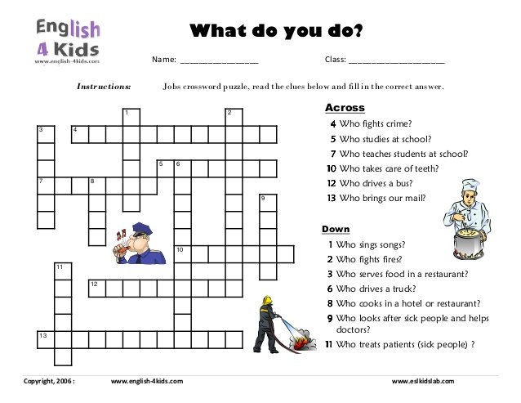

**ĐÁP ÁN:**

1. SINGER

2. FIRE-FIGHTER

3. WAITER

4. POLLICEOFFICE

5. STUDENT

6. TRUCKDRIVER

7. TEACHER

8. CHEF

9. NURSE

10. DENTIST

11. DOCTOR

12. BUSDRIVER

13. POSTSALWORKER