**UNIT 8: WHAT SUBJECTS DO YOU HAVE TODAY?**

**A. VOCABULARY**

|  |  |
| --- | --- |
| Lesson | Bài học |
| Subject | Môn học |
| Late | Muộn |
| Art | Nghệ thuật |
| Music | Âm nhạc |
| Maths/ Mathematics | Toán học |
| Informatics | Tin học |
| IT (Information Technology) | Công nghệ thông tin |
| PE (Physical Education) | Giáo dục thể chất |
| Gymnastics | Thể dục |
| English | Tiếng Anh |
| Vietnamese | Tiếng Việt |
| Science | Khoa học |
| History | Lịch sử |
| Geography | Địa lý |
| Every day | Mỗi ngày |
| Once | Một lần |
| Twice | Hai lần |
| And | Và |
| But | Nhưng |
| Late | Muộn |
| Early | Sớm |
| Have | Có (môn học gì) |

**B. GRAMMAR**

Bài học hôm nay chúng ta sẽ học các câu hỏi xoay quanh chủ đề môn học

**1. Hỏi đáp môn học trong 1 ngày cụ thể**

Câu hỏi: ***What subjects do you have + thời gian?***

Nếu chủ ngữ là he/ she/ tên người cụ thể thì ta thay thế do bằng does:

***What subjects does he/ she have + thời gian?***

Trả lời cho câu này: ***I have + môn học*** hoặc ***He/ she has + môn học.***

Các môn học được nối với nhau bởi “and”

VD:

What subjects do you have on Monday?

I have English and Vietnamese,

**2. Hỏi đáp khi nào có 1 môn học cụ thể**

Câu hỏi: **When do you have + môn học?**

Tương tự như trên, ta thay do bằng does với các chủ ngữ he/ she:

**When does he/ she have + môn học?**

Trả lời như sau: ***I have + môn học + on + thứ.*** Hoặc ***He/ she has + môn học + on + thứ.***

VD:

When does he have IT?

He has IT on Thursday.

**3. Hỏi đáp môn học ưa thích**

Có 2 cách hỏi môn học ưa thích thường gặp là:

Cách 1: ***What subject(s) do you like?***

Cách 2: ***What is your favourite subject(s)?***

Trả lời ngắn gọn: ***I like + môn học.***

**C. TASK**

***Exercise 1: Nối cột A với cột B***

|  |  |
| --- | --- |
| **A (Subjects)** | **B (What you learn in that subject)** |
| 1. Mathematics  2. History  3. English  4. Physical education  5. Geography  6. Vietnamese  7. Information Technology  8. Science | a. study what happened in the past  b. speak a foreign language  c. do exercise and learn to play sports  d. read and write Vietnamese  e. learn how to use the computer  f. study the world’s weather  g. learn about numbers and shapes  h. study basic things about human and the environment |

1-g 2-a 3-b 4-c 5-f 6-d 7-e 8-h

***Exercise 2: Điền tên môn học bằng tiếng Anh tương ứng với tranh***

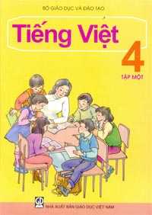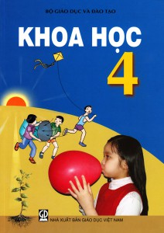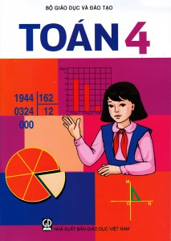

1.________________2.________________3.________________

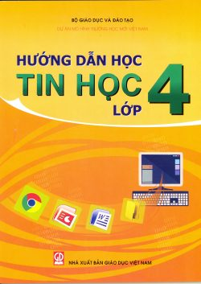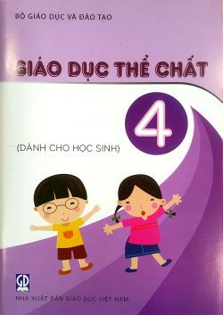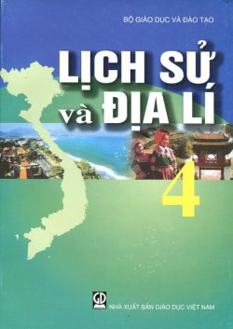

4.________________ 5.________________ 6.________________

**ĐÁP ÁN**

|  |  |  |
| --- | --- | --- |
| 1. Vietnamese | 2. Science | 3. Mathematics |
| 4. IT | 5. PE | 6. History & Geography |

***Exercise 3: Chọn đáp án đúng***

1. What _____________ do you like? I like English very much.

A. lesson B. subject C. activity D. homework

2. _____________ does she have PE? On Tuesday.

A. Where B. What C. When D. Why

3. I don’t like _____________ information technology.

A. studying B. study C. to study D. studies

4. They have Art, Vietnamese _____________ Music on Saturday.

A. but B. or C. and D. with

5. My sister likes playing tennis. I like playing tennis, _____________.

A. too B. so C. same D. of

6. What subjects _____________ he have on Wednesday?

A. is B. do C. to D. does

7. What _____________ Tom’s favourite subject? It’s Science.

A. be B. is C. are D. am

8. Do you _____________ studying Maths?

A. want B. have C. like D. are

**ĐÁP ÁN**

|  |  |  |  |
| --- | --- | --- | --- |
| 1. B | 2. C | 3. A | 4. C |
| 5. A | 6. D | 7. B | 8. C |

***Exercise 4: Điền từ thích hợp vào đoạn văn sau***

I’m Peter. I’m in (1) ________________ 4D. I am a student of Newton primary school. My favourite (2) ________________ is English. I often have English on Monday, Tuesday (3) ________________ Friday. Learning English (4) ______________ very interesting. In an English lesson, we learn how (5) ________________ listen, speak, read and write English. Ms. Clara is (6) ________________ teacher. She is (7) ________________ England. She teaches us (8) ________________ lot of exciting things about England. I love her so much.

1. A. school B. class C. late D. lesson

2. A. exercise B. day C. friend D. subject

3. A. and B. so C. but D. for

4. A. is B. quite C. with D. who

5. A. of B. go C. to D. have

6. A. their B. his C. her D. my

7. A. to B. from C. in D. on

8. A. a B. an C. the D. X

**ĐÁP ÁN**

|  |  |  |  |
| --- | --- | --- | --- |
| 1. B | 2. D | 3. A | 4. A |
| 5. C | 6. D | 7. B | 8. A |

***Exercise 5: Sắp xếp các từ sau thành câu hoàn chỉnh***

1. have/ English/ I/ on/ Thursday/ Monday/ and.

____________________________________________________________.

2. Her/ is/ favourite/ Maths/ subject.

____________________________________________________________.

3. subjects/does/ have/ today/ What/ he?

____________________________________________________________.

4. is/ for/ her/ She/ studying/ lesson/ Maths.

____________________________________________________________.

5. is/ teacher/ Who/ your/ Vietnamese/?

____________________________________________________________.

6. When/ English/ do/ have/ you?

____________________________________________________________.

7. Ms. Flora/ teacher/ her/ Art/ is.

____________________________________________________________.

8. today/Does/ have/ English/ she/?

____________________________________________________________.

9. We/ for/ are/ school/ late.

____________________________________________________________.

10. have/ doesn’t/ He/ today/ PE.

____________________________________________________________.

**ĐÁP ÁN:**

1. I have English on Monday and Thursday.

2. Her favourite subject is Maths.

3. What subjects does he have today?

4. she is studying for her Maths lesson.

5. Who is your Vietnamese teacher?

6. When do you have English?

7. Ms. Flora is her Art teacher.

8. Does she have English today?

9. We are late for school.

10. He doesn’t have PE today.