ĐỀ KIỂM TRA HỌC KỲ I LỚP 4 SỐ 1
Question 1: Chọn từ có cách phát âm khác với các từ còn lại
1. A. birthday B. play C. Japanese D. today
2. A. thin B. slim C. music D. five
3. A. mouse B. blouse C. cloud D. trousers
4. A. number B. student C. much D. cupboard
Question 2: Chọn đáp án đúng
1. What ___________ your nationality?
A. be B. is C. are D. was
2. How ___________ is your sister?
A. old B. much C. often D. long
3. ___________ do you have IT lesson?
A, How B. What C. Where D. When
4. – ___________ his mother a dentist? – Yes, she is.
A. Does B. Will C. Can D. Is
5. What day is ___________ today?
A. they B. he C. it D. you
6. My school is ___________ Nguyen Hoang street.
A. to B. in C. with D. of
Question 3: Nối cột A với cột B
A | B
1. Can you sing an English song?  2. What day is it today?  3. Is he 2 years younger than his brother?  4. Nice to meet you.  5. What does his mother do?  6. What do you like doing? | a. It’s Tuesday.  b. Nice to meet you, too.  c. Yes, I can.  d. I like dancing.  e. No, he is three years younger.  f. She is a housewife.

Question 4: Đọc đoạn văn và viết T (true) vào câu đúng, F (false) vào câu sai
Hi. My name is Mary. I’m twelve years old. I’m a pupil. I live in a beautiful area in a big city. Every morning I get up at 5:30 o’ clock. After that, I dress up at 6. I have breakfast in ten minutes and go to school at half past six. My school is near my house so I often go to school on foot. I love English so much. I can read English books and sing some English songs.
TRUE or FALSE?
1. Mary is 12 years old. ______________
2. She gets up at half past six. ______________
3. She goes to school on foot at 6:30. ______________
4. She can write English songs. ______________
Question 5: Sắp xếp các từ thành câu hoàn chỉnh
1. you/ subject/ like/ What/ do?
__________________________________________?
2. February/ My/ in/ is/ birthday?
__________________________________________.
3. very/ thank/ I’m/ you/ well.
__________________________________________.
4. Sandy/ now/ classroom/ in/ is/ the.
__________________________________________.

ĐỀ THI HỌC KỲ I LỚP 4 SỐ 2
Question 1: Chọn từ có cách phát âm khác với các từ còn lại
1. A. Friday B. fine C. listen D. light
2. A. paper B. watch C. date D. plane
3. A. home B. hobby C. volleyball D. October
4. A. room B. cool C. school D. book
Question 2: Chọn đáp án đúng
1. Tony is from Australia. He is ....................................
A. Australia B. Australias C. Australian D. Australist
2. Hakim is from Malaysia. .................................... nationality is Malaysian.
A. your B. our C. her D. his
3. What do you do ……….. Fridays? – I go to school in the morning.
A. in B. on C. at D. from
4. We have English on ………………………….
A. Mondays and Wednesdays
B. July and August
C. Mondays and September
D. November and December
5. What ………………. do you have today?
A. favourite B. district C. Maths D. subjects
6. ………… is your English teacher?
A. What B. How C. When D. Who
7. Where ……….. you this yesterday?
A. were B. was C. is D. are
8. I live ………………. Phu Quoc Island?
A. in B. on C. to D. at
Question 3: Đọc đoạn văn, viết YES ở câu đúng là No ở câu sai
Alex is a pupil at Sunflower Primary School. It is a big school in London. His school is in Sutton Street. There are many classrooms. They are beautiful. There is a library, a music room and a computer room. He loves his school.
1. His name is Alex. ...........................................
2. His school is small. ...........................................
3. His school is in Hanoi. ...........................................
4. He loves his school. ...........................................
Question 4: Chọn từ thích hợp để điền vào chỗ trống
primary | sing | November | Vietnam | name
Hi. My (1) ___________ is Nam. I’m from (2) _____________. I’m 11 years old. My birthday is on the third of (3) ____________. I study at Le Hong Phong (4) _____________ school. I like Music very much. In my free time, I go to Music club. I can (5) ______________ but I can’t play the violin.
Question 5: Sắp xếp các chữ cái để tạo thành từ đúng dựa vào tranh
1. APION ____________________ 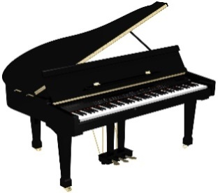
2. WREFLO ____________________ 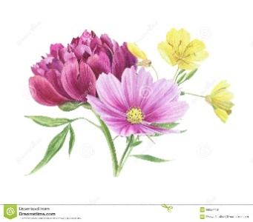
3. UMSCI ____________________ 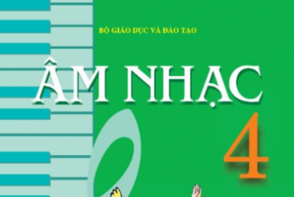
4. NTENSI ____________________

ĐỀ THI HỌC KỲ I LỚP 4 SỐ 3
Question 1: Chọn từ có cách phát âm khác với các từ còn lại
1. A. music B. district C. city D. fire
2. A. walk B. class C. glasses D. badminton
3. A. student B. study C. much D. umbrella
4. A. name B. same C. game D. lamp
Question 2: Chọn đáp án đúng
1. Sandra likes ___________ to music.
A. listening B. listen C. to listen D. listen
2. He can play football _______ he can’t play table tennis.
A. because B. and C. but D. when
3. Where is she _______? – She’s from Japan.
A. in B. from C. at D. on
4. Where _______ you yesterday?
A. is B. are C. was D. were
5. What _______does Mai have today? – She has Math, Music, Science and English.
A. class B. subjects C. time D. nationality
6. _______ day is it today? –It’s Monday.
A. Why B. What C. When D. How
Question 3: Đọc đoạn văn và chọn đáp án đúng điền vào chỗ trống
This is my mother. (1)_________ name is Hien. She is a teacher. She gets up at 5:30 in the morning. She has (2)_________ at 6 o’clock. She goes to work at 6:30. She works in a school from 7 o’clock a. m. (3)_________ 10:30 a.m. She arrives home at 11:00 a.m. She has lunch at 11:30. In the evening she has dinner and she (4)_________ to bed at 11 p.m.
1. A. his B. your C. her D. their
2. A. breakfast B. class C. dinner D. lunch
3. A. at B. of C. with D. to
4. A. tells B. plays C. goes D. looks
Question 4: Sắp xếp các từ sau thành câu hoàn chỉnh
1. subjects / today? / do / have / What / you
..........................................................................................................................
2. Nice / to / again. / you / see
............................................................................................................................
3. class / in? / they / are / What
............................................................................................................................
4. did / yesterday? / they / do / What
............................................................................................................................
Question 5: Dựa vào tranh hoàn thành các câu sau
1. This is my ___________. It’s big.
2. How ___________ is she? She is five years old.
3. He comes from ___________.
4. I like ___________ my bike.

ĐỀ THI HỌC KỲ I LỚP 4 SỐ 4
Question 1: Chọn từ khác loại
1. A. yesterday B. went C. had D. got
2. A. date B. Monday C. Tuesday D. Thursday
3. A. fly B. plane C. write D. read
4. A. England B. Japan C. America D. November
Question 2: Chọn từ thích hợp điền vào chỗ trống
English favourite today in Tuesday
A: What day is it (1).................................., Nam?
B: It’s (2)........................................
A: What subjects do you have today?
B: I have Maths, Science, Music and (3)...........................................
A: What is your (4)......................................... subjects?
B: Maths and English.
Question 3: Đọc đoạn văn và trả lời câu hỏi
This is my new friend. His name is Peter. He is from America. He is a pupil at Hanoi International School. His hobby is playing football and reading books. He can sing many Vietnamese songs. In his free time, he often goes to the music club. He is happy there.
1. Where is Peter from?
............................................................................................................................
2. What is his hobby?
............................................................................................................................
3. Can he sing Vietnamese songs?
............................................................................................................................
4. What does he do in his free time?
............................................................................................................................
Question 4: Tìm lỗi sai trong các câu sau và sửa lại cho đúng
1. What subject does you have today? ____________________
2. He are from Malaysia. ____________________
3. I go from Quynh Hai primary school. ____________________
4. They have English yesterday. ____________________
Question 5: Dựa vào tranh hoàn thành các câu sau
1. I have ____________ on Tuesday. 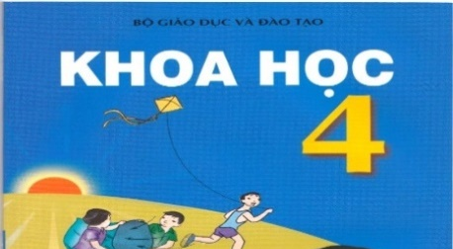
2. She is reading a ____________ now.
3. Today is the ____________ of October.
4. They are ____________.

ĐỀ THI HỌC KỲ I LỚP 4 SỐ 5
Question 1: Chọn từ khác loại
1. A. about B. where C. how D. who
2. A. collect B. read C. do D. like
3. A. Art B. Music C. subject D. History
4. A. blue B. puppet C. purple D. red
Question 2: Dựa vào tranh để hoàn thành các câu sau
1. She is ______________ a dictation.
2. Women’s Day is in _________________.
3. I have __________________ today.
4. They _____________ for a walk yesterday.
Question 3: Chọn từ thích hợp trong hộp thoại để điền vào chỗ trống
happy England friend dance club
This is my new (1) ______________. Her name is Linda. She is from (2) ______________. She can sing many Vietnamese songs. In her free time, she goes to music (3) ______________. She is (4) ______________ there.
1. | 2.
3. | 4.
Question 4: Tìm lỗi sai trong các câu sau và sửa lại cho đúng
1. She don’t like playing badminton. _____________________
2. Sandy is an pupil at Hong Bang primary school. _____________________
3. We have English in Friday. _____________________
4. My birthday is on the twenty of December. _____________________
Question 5: Sắp xếp các từ sau thành câu hoàn chỉnh
1. a/ fly/ want/ I/ to/ kite/.
____________________________________________________
2. They/ school/ yesterday/ went/ to.
____________________________________________________
3. When/ birthday/ your/ is/?
____________________________________________________
4. can/ cannot/ jump high/ Tom/ but/ run fast/.
____________________________________________________
5. Monday/ has/ on/ Tom/ PE/.
____________________________________________________
6. doing/ What/ they/ are/?
____________________________________________________

