|  |  |
| --- | --- |
| **PHÒNG GD& ĐT**  **TRƯỜNG TIỂU HỌC…….** | **BÀI KIỂM TRA GIỮA HỌC KÌ I**  **Môn: Tiếng Anh 4 ( Thí điểm)**  **Thời gian: 45 phút**  **(Không kể thời gian giao đề)** |

**Đề 1**

**I. Read and choose the correct answer.**

1. Her birthday is (on/ at) the first of September.

2. Where is Anna from? (He/ She) is from America.

3. What (do/ does) Huynh do on Sundays? - He visits his grandparents.

4. (Can/ Do) you play the guitar? - No, I can't.

5. (What/ Where) nationality are you? - I am Japanese.

**II. Read and number the sentence to make a complete conversation.**

|  |  |
| --- | --- |
|  | A. I can't play the guitar but I can sing. |
|  | B. Nice to meet you, too, Tom. What day is it today? |
|  | C. What can you do? |
|  | D. It is Wednesday. |
| 0 | E. Nice to meet you, Peter. |
|  | F. I can play the guitar. What about you? |

**III. Fill the blanks.**

1. Can you swim? _____, I can.

2. ______'s your birthday? In December.

3. What _______ is she? - She is Chinese.

4. What does she _____ in the morning? She gets up and has breakfast.

5. _______ are you from? - I am from Vietnam.

**IV. Read and complete the sentence.**

Hello, My name's Lien. I am from Vietnam. I am Vietnamese. I can sing but I can't draw a picture. I often help my mom cook the meals on Sunday.

1. My name is ________.

2. Lien is _____________.

3. Lien can _________.

4. Lan ______ draw a picture.

5. Lien ______ her mom cook on _______.

**IV. Put the words in order.**

1. It/ Monday/ on/ is/ ./

___________________________

2. Can/ the/ piano/ play/ you/ ?/

___________________________

3. What/ today/ it/ day/ is/ ?/

___________________________

4. birthday/ May/ fifth/ My/ on/ is/ of/ the/ ./

___________________________

5. Saturdays/ does/ What/ do/ she/ on/ ?/

___________________________

|  |  |
| --- | --- |
| **PHÒNG GD& ĐT**  **TRƯỜNG TIỂU HỌC…….** | **BÀI KIỂM TRA GIỮA HỌC KÌ I**  **Môn: Tiếng Anh 4 ( Thí điểm)**  **Thời gian: 45 phút**  **(Không kể thời gian giao đề)** |

**Đề 2**

**I. Chọn từ khác loại.**

|  |  |  |  |
| --- | --- | --- | --- |
| 1. A. school | B. skate | C. play | D. sing |
| 2. A. she | B. he | C. them | D. it |
| 3. A. Malaysian | B. Chinese | C. Japanese | D. Paris |
| 4. A. high | B. tall | C. short | D. fine |
| 5. A. playing | B. morning | C. singing | D. going |

**II. Read and choose the correct answer.**

1. When's your birthday?

A. It's Tuesday.

B. It 's at next Monday.

C. It's on the sixth of June.

2. _______________? - I can do aerobics.

A. Can you draw?

B. What can you do?

C. What she can do?

3. What nationality is Linda?

A. She is English.

B. She is from England.

C. She is nine.

4. Goodbye, Lan.

A. Bye, Linda.

B. Good morning, I am Lan.

C. Stand up

5. Can you dance?

A. No, you can't.

B. Yes, she can

C. Yes, I can.

**III. Read and match.**

|  |  |
| --- | --- |
| 1. Where are you from? | A. She can dance. |
| 2. What can she do? | B. No, I can't. |
| 3. What day is it today? | C. Good morning, Ana. |
| 4. Can you play the piano? | D. It is Thursday. |
| 5. Good morning, Linda. | E. I am from France. |

**IV. Put the words in order.**

1. It/ Monday/ on/ is/ ./

___________________________

2. Can/ the/ piano/ play/ you/ ?/

___________________________

3. What/ today/ it/ day/ is/ ?/

___________________________

4. birthday/ May/ fifth/ My/ on/ is/ of/ the/ ./

___________________________

5. Saturdays/ does/ What/ do/ she/ on/ ?/

|  |  |
| --- | --- |
| **PHÒNG GD& ĐT**  **TRƯỜNG TIỂU HỌC…….** | **BÀI KIỂM TRA GIỮA HỌC KÌ I**  **Môn: Tiếng Anh 4 ( Thí điểm)**  **Thời gian: 45 phút**  **(Không kể thời gian giao đề)** |

**Đề 3**

**I. Chọn từ khác loại**

|  |  |  |  |
| --- | --- | --- | --- |
| 1. A. Japanese | B. American | C. English | D. nationality |
| 2. A. from | B. at | C. How | C. in |
| 3. A. English | B. Monday | C. Physics | D. Maths |
| 4. A. piano | B. aerobics | C. badminton | C. guitar |
| 5. A. How | B. Why | C. Where | D. Hi |

**II. Tìm lỗi sai và sửa.**

1. When are Linh birthday?

2. What is he name?

3. I go to school in Monday.

4. Linda have birthday party today.

5. I am in Nha Trang next holiday.

**III. Chọn đáp án đúng**

1. Where is Peter from? __________ from England.

A. I am

B. She is

C. He is

D. He are

2. Good morning. This is my friend, her __________ Mary.

A. name

B. name’s

C. named

D. names

3. This ______ Akiko. She is from Japan.

A. is

B. are

C. was

D. were

4. ________ day is the it today?

A. Where

B. What

C. When

D. How

5. _________to meet you again.

A. Nine

B. She

C. They

D. Nice

6. What is your nationality?

A. I’m from Malaysia.

C. I’m Japanese.

B. I from Japan.

D. I Malaysian.

7. .................. you draw? ................., I can't.

A. Can/ No

B. Cannot/ Yes

C. Can/ Yes

D. Can/ Not

8. My birthday is on the fifth ____ October.

A. in

B. at

C. on

D. of

**IV. Read and answer the questions.**

Hi. I am Anna. I am from America. I am American. Today is Wednesday, the seventh of October. It's a school day. I go to school from Monday to Friday. And I do not go to school at the weekend. On Monday afternoon, I go to the English club. I go to school library on Tuesday with my best friends, Linda. On Thursday, I go swimming on Wednesday afternoon. I visit my grandparents on Saturday and Sunday.

1. What is her name?

2. When does she go to school?

3. When does she go swimming?

4. What does she do on Monday afternoon?

5. What does she do on Sunday?

|  |  |
| --- | --- |
| **PHÒNG GD& ĐT**  **TRƯỜNG TIỂU HỌC…….** | **BÀI KIỂM TRA GIỮA HỌC KÌ I**  **Môn: Tiếng Anh 4 ( Thí điểm)**  **Thời gian: 45 phút**  **(Không kể thời gian giao đề)** |

**Đề 4**

**I. Chọn từ khác loại.**

|  |  |  |  |
| --- | --- | --- | --- |
| 1. A. Science | B. Vietnam | C. English | D. Vietnamese |
| 2. A. Well | B. What | C. Who | D. Why |
| 3. A. map | B. photo | C. poster | D. Australia |
| 4. A. Cook | B. walk | C. Go | D. Does |
| 5. A. today | B. Monday | C. Friday | D. Thursday |

**II. Chọn từ có phần gạch chân phát âm khác.**

|  |  |  |  |
| --- | --- | --- | --- |
| 1. A. music | B. build | C. cut | D. student |
| 2. A. foot | B. book | C. good | D. moon |
| 3. A. Sunday | B. come | C. home | D. some |
| 4. A. holiday | B. many | C. stay | D. date |

**III. Điền chữ cái thích hợp vào chỗ trống**

1. N_ce t_ see _ou again.

2. She is a p_p_ _ in Cau Giau primary.

3. W_ere a_ _ you f_om? - I am from Ha Noi.

4. T_ _ay is W_dn_sd_y.

5. I'm f_ne, tha_ _ you.

6. My br_ thday is in De_ _mber.

**IV. Hoàn thành hội thoại dựa vào các từ cho trước.**

**Do; name; and; sing; meet;**

Anna: Hi. I’m Anna. What’s your (1) ___________?

Tom: My name is Tom. Nice to meet you.

Anna: Nice to (2)_______you, too.

Tom: What is your nationality?

Anna: I’m English. (3) ___________ you?

Tom: I’m American. Can you (4) _______ any English songs?

Anna: Yes, I can. I can sing and dance. Do you like playing the piano?

Tom: Yes, I (5) ___________. I want to learn to play it.

Anna:  I can teach you.

Tom: That’s great.

|  |  |
| --- | --- |
| **PHÒNG GD& ĐT**  **TRƯỜNG TIỂU HỌC…….** | **BÀI KIỂM TRA GIỮA HỌC KÌ I**  **Môn: Tiếng Anh 4 ( Thí điểm)**  **Thời gian: 45 phút**  **(Không kể thời gian giao đề)** |

### Đề 5

### Đề thi giữa kì 1 lớp 4 môn tiếng Anh số 2 có đáp án - Đề 4

**I. Sắp xếp các từ để tạo thành câu hoàn chỉnh**

1. Linh/ subjects/ today/ What/ have/ does?

___________________________________________________?

2. Can/ a / bike/ you/ ride?

___________________________________________________?

3. letter/ a/ I/ writing/ am/ now.

___________________________________________________.

4. He/ very/ cooking/ much/ hates.

___________________________________________________.

**II. Cho dạng đúng của các động từ sau**

**1.** She cannot (climb) _________________ the wall.

**2.** When (be) _________________ her birthday?

**3.** I (visit) _________________ my grandparents yesterday.

**4.** What ______________ he (do) ______________ now?

**5.** She (play) _________________ the guitar now.

**III. Nối câu hỏi ở cột A với câu trả lời thích hợp ở cột B**

|  |  |
| --- | --- |
| **A** | **B** |
| 1. What is Mrs. Lan doing?  2. Where are you from?  3. Can your sister cook meal?  4. What is Emma’s nationality?  5. What do they have on Monday? | a, No, she cann't.  b, They have Math and PE.  c, She is English.  d, She is playing the piano.  e, I am from Hanoi, Vietnam. |

**IV. Viết các tháng trong năm theo đúng nghĩa**

MAY DECEMBER JUNE

FEBRUARY OCTOBER APRIL

MARCH JULY SEPTEMBER

JANUARY AUGUST NOVEMBER

|  |  |  |  |
| --- | --- | --- | --- |
| Tháng 1 - | Tháng 2 - | Tháng 3 - | Tháng 4 - |
| Tháng 5 - | Tháng 6 - | Tháng 7 - | Tháng 8 - |
| Tháng 9 - | Tháng 10 - | Tháng 11 - | Tháng 12 - |

|  |  |
| --- | --- |
| **PHÒNG GD& ĐT**  **TRƯỜNG TIỂU HỌC…….** | **BÀI KIỂM TRA GIỮA HỌC KÌ I**  **Môn: Tiếng Anh 4 ( Thí điểm)**  **Thời gian: 45 phút**  **(Không kể thời gian giao đề)** |

### Đề 6

**I. Choose the odd one out.**

|  |  |  |  |
| --- | --- | --- | --- |
| 1. A. morning | B. evening | C. afternoon | D. birthday |
| 2. A. Japan | B. American | C. English | D. Vietnamese |
| 3. A. Monday | B. birthday | C. Friday | D. Tuesday |
| 4. A. second | B. third | C. five | D. fifth |
| 5. A. piano | B. badminton | C. football | C. volleyball |

**II. Read and match.**

|  |  |
| --- | --- |
| A | B |
| 1. Nice to see you again. | a. He is from Canada. |
| 2. Can he play the piano? | b. Next Monday. |
| 3. Where is Peter from? | c. Nice to see you again, too. |
| 4. What day is it today? | d. It is Wednesday. |
| 5. When is your mother's birthday party? | e. No, he can't. |

**III. Viết 1 đoạn văn ngắn từ 3-5 câu về bản thân em.**

Đoạn văn bao gồm các ý dưới đây:

- What’s your name?

- How old are you?

- When is your birthday?

- What subject do you like?

- What can you do?

|  |  |
| --- | --- |
| **PHÒNG GD& ĐT**  **TRƯỜNG TIỂU HỌC…….** | **BÀI KIỂM TRA GIỮA HỌC KÌ I**  **Môn: Tiếng Anh 4 ( Thí điểm)**  **Thời gian: 45 phút**  **(Không kể thời gian giao đề)** |

**Đề 7**

***Exercise 1: Chọn từ có cách phát âm khác với các từ còn lại***

**1.** A. pupil                  B. music                     C. sun                        D. student

**2.** A. football               B. book                       C. good                       D. food

**3.** A. Monday              B. come                      C. from                       D. some

**4.** A. skate                  B. can                         C. may                        D. date

***Exercise 2: Điền chữ cái thích hợp vào chỗ trống***

**1.** It’s n_ce t_ meet _ou.

**2.** I’m a p_p_ _.

**3.** W_ere a_ _ you f_om?

**4.** T_ _ay is S_nd_y.

**5.** Tha_ _ you very   _uch.

**6.** My b_ thday is in Fe_ _uary

***Exercise 3: Gạch chân lỗi sai và sửa lại cho đúng***

|  |  |
| --- | --- |
| 1. What is your birthday? | __________________ |
| 2. What is she name? | __________________ |
| 3. I don’t go to school at Sunday. | __________________ |
| 4. Tom have an Art class today. | __________________ |

***Exercise 4: Hoàn thành hội thoại dựa vào các từ cho trước***

|  |
| --- |
| **do      name      What      an      too** |

Bob:   Hi. I’m Bob. What’s your (1) ___________?

Clara: My name is Clara. Nice to meet you.

Bob:   Nice to meet you, (2) ___________.

Clara: What is your nationality?

Bob:   I’m American. (3) ___________ about you?

Clara: I’m English. Can you sing (4) ___________ English song?

Bob:   Yes, I can. I can sing and dance. Do you like playing the guitar?

Clara: Yes, I (5) ___________. I want to learn to play it.

Bob:   I can teach you.

Clara: That’s great.

***Exercise 5: Sắp xếp các từ để tạo thành câu hoàn chỉnh***

**1.** you/ subjects/ today/ What/ have/ do?

___________________________________________________?

**2.** Can/ football/ you/ play?

___________________________________________________?

**3.** email/ an/ I/ writing/ am.

___________________________________________________.

**4.** She/ very/ cooking/ much/ likes.

___________________________________________________.

***Exercise 6: Viết 1 đoạn văn ngắn từ 3-5 câu về bản thân em***

**Gợi ý:**

- What’s your name?

- How old are you?

- When is your birthday?

- What subject do you like?

- What can you do?

_______________________________________________________________________________________________________________________________________________________________________________________________________________\

|  |  |
| --- | --- |
| **PHÒNG GD& ĐT**  **TRƯỜNG TIỂU HỌC…….** | **BÀI KIỂM TRA GIỮA HỌC KÌ I**  **Môn: Tiếng Anh 4 ( Thí điểm)**  **Thời gian: 45 phút**  **(Không kể thời gian giao đề)** |

**Đề 8**

***Exercise 1: Chọn từ khác loại***

**1.** A. Math      B. Name     C. English      D. Vietnamese

**2.** A. Where      B. What     C. Why      D. Can

**3.** A. Country      B. Singapore     C. China      D. Australia

**4.** A. Cook B.      Play     C. Go      D. Would

**5.** A. Birthday      B. Monday     C. Friday      D. Thursday

**6.** A. Was      B. Am     C. Is      D. Are

**7.** A. On      B. To     C. Be      D. For

**8.** A. Japanese      B. America     C. Cambodia      D. Malaysia

***Exercise 2: Cho dạng đúng của các động từ sau***

**1.** He can (climb) _________________ the trees.

**2.** When (be) _________________ your birthday?

**3.** I (stay) _________________ at home yesterday.

**4.** What ______________ they (do) ______________ now?

**5.** They (play) _________________ the piano now.

**6.** Today she (have) _________________ English and history.

**7.** What day (be) _________________ it today?

**8.** Tommy and Vicky (be) _________________ from Korea.

. ***Exercise 3: Nối câu hỏi ở cột A với câu trả lời thích hợp ở cột B***

|  |  |
| --- | --- |
| **A** | **B** |
| **1.** What is Mr. Long doing?  **2.** When is his birthday?  **3.** Where are you from?  **4.** Where were you yesterday?  **5.** Can he cook?  **6.** What is Hanna’s nationality?  **7.** What do they have on Wednesday?  **8.** What do you like doing? | **a,** Yes, he can.  **b,** I am from Vietnam.  **c,** I like dancing and singing.  **d,** His birthday is in October.  **e,** She is Japanese.  **f,** I was at home yesterday.  **g,** He is teaching a lesson.  **h,** They have Math and PE. |

***Exercise 4: Dựa vào tranh và hoàn thành câu***



**1.** He comes from ______________.



**2.** I cannot ____________.



**3.** My birthday is ___________ March.



**4.** I go to Quang Trung ____________ school.

***Exercise 5: Sắp xếp các từ để tạo thành câu hoàn chỉnh***

**1.** you/ subjects/ today/ What/ have/ do?

___________________________________________________?

**2.** Can/ football/ you/ play?

___________________________________________________?

**3.** email/ an/ I/ writing/ am.

___________________________________________________.

**4.** She/ very/ cooking/ much/ likes.

___________________________________________________.

|  |  |
| --- | --- |
| **PHÒNG GD& ĐT**  **TRƯỜNG TIỂU HỌC…….** | **BÀI KIỂM TRA GIỮA HỌC KÌ I**  **Môn: Tiếng Anh 4 ( Thí điểm)**  **Thời gian: 45 phút**  **(Không kể thời gian giao đề)** |

|  |  |  |  |  |  |  |  |  |  |  |  |  |  |  |  |  |  |  |  |  |  |  |  |  |  |  |  |  |  |  |  |  |  |  |  |  |  |
| --- | --- | --- | --- | --- | --- | --- | --- | --- | --- | --- | --- | --- | --- | --- | --- | --- | --- | --- | --- | --- | --- | --- | --- | --- | --- | --- | --- | --- | --- | --- | --- | --- | --- | --- | --- | --- | --- |
| **Đề 9**  ***Exercise 1: Dùng các từ cho sẵn hoàn thành đoạn hội thoại sau***   |  | | --- | | **playing           What             listening           flying** |   A: I have a new kite. Let’s fly it.  B: I’m sorry but I don’t like (1) ___________ kites.  A: (2) ___________ do you like doing?  B: I like (3) ___________ to music and (4) ____________ football.  What about you?  A: I like playing football, too.  B: Ok. Let’s play.   |  |  | | --- | --- | | 1. | 2. | | 3. | 4. |   ***Exercise 2: Viết các tháng trong năm theo đúng thứ tự***  **MAY               DECEMBER             JUNE**  **FEBRUARY              OCTOBER                APRIL**  **MARCH          JULY              SEPTEMBER**  **JANUARY      AUGUST         NOVEMBER**   |  |  | | --- | --- | | **1.** ________________ | **7.** ________________ | | **2.** ________________ | **8.** ________________ | | **3.** ________________ | **9.** ________________ | | **4.** ________________ | **10.** _______________ | | **5.** ________________ | **11.** _______________ | | **6.** ________________ | **12.** _______________ |   ***Exercise 3: Chọn từ khác loại***  **1.** A. ski                     B. skip                       C. school                    D. skate  **2.** A. he                      B. her                       C. you                        D. they  **3.** A. flag                    B. Malaysia                C. Singapore               D. China  **4.** A. nice                    B. name                    C. class                      D. pupil  ***Exercise 4: Sắp xếp các câu sau thành đoạn hội thoại hoàn chỉnh***  ☐ Hi. It’s nice to see you. I’m from England. But I live in Hanoi now.  ☐ Nice to meet you, Tom. Where are you from?  ☐ Yes, I am. I love learning Vietnamese.  ☐ No, I can’t speak it fluently.  ☐ Oh I’m in Hanoi, too. Are you a pupil?  ☐ Hey, Anna. This is my friend, Tom.  ☐ Wow! Can you speak Vietnamese?  Đề thi Tiếng Anh 4 Giữa học kì 1 có đáp án (Đề 2)  ***Exercise 5: Read and write T/ F***  Hello, my name is Akio. I am from Japan. I’m Japanese. I speak Japanese and English. My school is an international school. It is Rose International School. I have got a lot of friends. There are twenty students in my class. They are from different countries. Linda is from England. She is English. Jack and Jill are from the USA. They are American. Meimei is from Malaysia. She is Malaysian. Alex is from Australia. We often play badminton, play hide-and-seek together. It is a lot of fun.  **TRUE or FALSE?**   |  |  | | --- | --- | | 1. She is Akio. |  | | 2. She is Vietnamese. |  | | 3. Her school is International School. |  | | 4. Her class has got twelve students. |  | | 5. Her friends are from Vietnam. |  | | 6. Jack is from America. |  | | 7. Meimei isn’t Japanese. |  | | 8. Alex is Australian. |  | | 9. They play games together. |  | | 10. They are happy. |  | |

|  |  |
| --- | --- |
| **PHÒNG GD& ĐT**  **TRƯỜNG TIỂU HỌC…….** | **BÀI KIỂM TRA GIỮA HỌC KÌ I**  **Môn: Tiếng Anh 4 ( Thí điểm)**  **Thời gian: 45 phút**  **(Không kể thời gian giao đề)** |

**Đề 10**

***Exercise 1: Chọn từ khác loại***

**1.** A. Sunday                 B. Birthday                  C. Saturday                   D. Wednesday

**2.** A. school                 B. go                           C. come                       D. have

**3.** A. December            B. October                   C. Australia                 D. March

**4.** A. cook                    B. skip                         C. skate                       D. can

***Exercise 2: Sắp xếp các từ sau thành câu hoàn chỉnh***

**1.** you/ What/ nationality/ are?

___________________________________________________________.

**2.** have/ They/ Tuesday/ Math/ on.

___________________________________________________________.

**3.** play/ She/ cannot/ baseball.

___________________________________________________________.

**4.** it/ day/ What/ today/ is/?

___________________________________________________________.

**Exercise 3: Hoàn thành đoạn văn sau**

|  |
| --- |
| **can’t, Japanese, December, singing, Japan, cooking** |

My name is Akio. I am from (1)....................... I am (2).......................... I am ten years old. My birthday is in (3) .......................... I can use a computer but I (4) ................ play the piano. My hobby is (5)............ .................... and (6)...... .......................Vietnamese songs. What about you?

**Exercise 4: Nghe và nối**

a. b. c. d.

|  |  |  |  |  |  |  |  |
| --- | --- | --- | --- | --- | --- | --- | --- |
| 271020143973   |  |  |  |  | | --- | --- | --- | --- | |  |  |  |  | | 271020143978 | 271020143995 | 271020144011 |

**Listen and number (1 m)**

|  |  |  |  |
| --- | --- | --- | --- |
| 271020143998  A  271020144017 |  | 271020144020  B  271020144026 |  |

**Listen and tick (**  **)(1m)**

1. What can you do?

|  |  |  |  |
| --- | --- | --- | --- |
| 271020144016  A |  | 271020144012  B |  |

1. Do you like playing chess?

|  |  |  |  |
| --- | --- | --- | --- |
| 271020144030  A |  | 271020144034  B |  |

1. Where are you from?

|  |  |  |  |
| --- | --- | --- | --- |
| 271020144000A |  | B |  |

1. When is your bithday?

|  |  |  |  |
| --- | --- | --- | --- |
| 271020144050  A |  | 271020144048  B |  |

***Exercise 5: Dịch các câu sau sang tiếng Anh***

**1.** Cô ấy là một học sinh.

___________________________________________________

**2.** Anh ấy đến từ nước Mỹ.

___________________________________________________

**3.** Cảm ơn bạn rất nhiều.

___________________________________________________

4.Hôm nay là thứ mấy?

|  |  |
| --- | --- |
| **PHÒNG GD& ĐT**  **TRƯỜNG TIỂU HỌC…….** | **BÀI KIỂM TRA GIỮA HỌC KÌ I**  **Môn: Tiếng Anh 4 ( Thí điểm)**  **Thời gian: 45 phút**  **(Không kể thời gian giao đề)** |

**Đề 11**

**Exercise 1. Đọc và nối**

|  |  |
| --- | --- |
| 1. Where are you from? | A. I'm in class 4A. |
| 2. What class are you in? | B. She can dance. |
| 3. What's the date today? | C. I am from Vietnam. |
| 4. What can she do? | D. It is 29th of October. |

**Exercise 2. Đọc và điền Yes/ NO**

Alex is a pupil at Sunflower Primary School. It is a big school in London. His school is in Sutton Street. There are many classrooms. They are beautiful. There is a library, a music room and a computer room. He loves his school.

1. His name is Alex …………………………………….
2. His school is small …………………………………….
3. His school is in Ha Noi …………………………………….

He loves his school …………………………………….

***Exercise 3: Sắp xếp các từ sau thành câu hoàn chỉnh***

**1.** very/ can/ brother/ high/ My/ jump.

___________________________________________________________.

**2.** What/ he/ have/ today/ does/ subject?

___________________________________________________________?

**3.** Math/ When/ have/ we/ do?

___________________________________________________________?

**4.** from/ I/ Monday/ go to/ to/ Friday/ school/ primary.

___________________________________________________________.

***Exercise 4: Gạch chân và sửa lỗi sai trong mỗi câu sau***

|  |  |
| --- | --- |
| 1. He can plays the piano. | ______________________ |
| 2. Where do you from? | ______________________ |
| 3. It are on the fifth of April. | ______________________ |
| 4. Do you have History in Thursday? | ______________________ |

***Exercise 5: Sắp xếp các từ sau thành câu hoàn chỉnh***

**1.** old/ How/ Lan/is/?

………………………………………………………

**2.** 9 people/ There/ are/ in their/ family/.

……………………………………………………………………………

**3.** you/ play/ Can/ guitar/ the/drum/ the?

……………………………………………………………………………

**4.** is/ My/ Japan/ from/ teacher.

……………………………………………………………………………

|  |  |
| --- | --- |
| **PHÒNG GD& ĐT**  **TRƯỜNG TIỂU HỌC…….** | **BÀI KIỂM TRA GIỮA HỌC KÌ I**  **Môn: Tiếng Anh 4 ( Thí điểm)**  **Thời gian: 45 phút**  **(Không kể thời gian giao đề)** |

**ĐỀ 12**

***Exercise 1: Chọn đáp án đúng***

**1. Where are you from, Tom? __________ from America.**

A. I am                         B. My name

C. You are                    D. Her name

**2. Hello, my __________ is Mary.**

A. name                        B. name’s

C. named                       D. names

**3. This ______ my friend, Linda. She is from England.**

A. is                             B. are

C. was                          D. were

**4. ________ is the date today?**

A. Where                      B. What

C. When                       D. How

**5. _________to meet you, too.**

A. Fine                         B. She

C. They                       D. Nice

**6. Where are you from?**

A. I’m from Malaysia.

C. I’m an Japanese.

B. I from Japan.

D. I Malaysian.

**7. .................. you sing? ................., I can.**

A. Can/ No                    B. Cannot/ Yes

C. Can/ Yes                   D. Can/ Not

**8. My birthday is on the .................. of October.**

A. Thursday                   B. two

C. ten                            D. fifth

**Ex 2: Listen and write the missing words or numbers (2ms)**

1. What is your hobby?

My hobby is ............................................................

1. Good mornging, Peter. How are you?

Good morning, Linda. I’m very ................, thanks.

1. Can you play chess?

No, I can’t, but I can ....................................................

1. When’s your birthday?

It’s the second of .............................

**Exercise 3: Look and read. Put the tick (**  **) or cross( X ) in the box**

**(1m)**

1.

|  |  |  |
| --- | --- | --- |
| images | I like playing badminton |  |

2.

|  |  |  |
| --- | --- | --- |
|  | She can ride a bike. |  |

3.

|  |  |  |
| --- | --- | --- |
| 271020144002 | He is from Australia and he is Australian. |  |

4

|  |  |  |
| --- | --- | --- |
| 271020144045 | My hobby is drawing. |  |

**Ex 4 : Look and read. Write YES or NO (1m)**

This is Peter. He is from England. He is a student at Doan Thi Diem School. His birthday is the second of January. He can ride a bike and swim. His hobby is dancing. In his free time he goes to the music club. He is happy there.

1. He is from England. ……….
2. He like playing football. ……….
3. He can ride a bike and swim. ………..
4. He is bored there. ………..

**Ex5 : Look at the pictures and complete the sentences (1m)**

|  |  |
| --- | --- |
| 271020144013 | 1. I can s.............................................. |

|  |  |
| --- | --- |
| 271020144038 | 2. ................ can you do?  I can ride a bike. |

|  |  |
| --- | --- |
| 271020143996 | 3.Where are you from?  I am from ......................... |

|  |  |
| --- | --- |
| 271020144041 | 4. I like li.............................................. |

***Exercise 6: Dùng các từ cho sẵn hoàn thành đoạn hội thoại sau***

|  |
| --- |
| **playing           What             listening           flying** |

A: I have a new kite. Let’s fly it.

B: I’m sorry but I don’t like (1) ___________ kites.

A: (2) ___________ do you like doing?

B: I like (3) ___________ to music and (4) ____________ football.

What about you?

A: I like playing football, too.

B: Ok. Let’s play.

|  |  |
| --- | --- |
| 1. | 2. |
| 3. | 4. |

|  |  |
| --- | --- |
| **PHÒNG GD& ĐT**  **TRƯỜNG TIỂU HỌC…….** | **BÀI KIỂM TRA GIỮA HỌC KÌ I**  **Môn: Tiếng Anh 4 ( Thí điểm)**  **Thời gian: 45 phút**  **(Không kể thời gian giao đề)** |

**ĐỀ 13**

**Bài 1. Hãy quan sát kỹ bức tranh rồi điền chữ cái chỉ bức tranh đó (2,5 điểm).**

A. rubber B. plane C. badminton

D. cooking E. watch TV F. Maths

|  |  |  |
| --- | --- | --- |
| Ví dụ: 1. A | 2. ……. | 3. … |
| 4. ……. | 5. …… | 6. …….. |

**Bài 2. Đọc đoạn văn sau và tích vào câu đúng (T) hoặc sai (F) (2,5 điểm)**

It is Friday today. We are having a break. We are doing exercise in the school playground.

Phong is jumping. Linda and Mai are playing badminton. Nam and Tom are skipping.

Quan and Peter are playing basketball. We are having a lot of fun here.

|  |  |  |  |
| --- | --- | --- | --- |
|  | **T** |  | **F** |
| 1. We are doing exercise in the school gym. |  |  |  |
| 2. Phong is skipping. |  |  |  |
| 3. Linda and Peter are playing badminton. |  |  |  |
| 4. Nam and Tom are skipping. |  |  |  |
| 5. Quan and Peter are playing table tennis. |  |  |  |

**Bài 3. Đọc và nối (2,5 điểm)**

|  |  |
| --- | --- |
| 1. Where are you from? | A. I can play volleyball. |
| 2. What day is it today? | B. I watched TV. |
| 3. What can you do? | C. I’m from Japan. |
| 4. What’s he doing? | D. It’s Wednesday. |
| 5. What did you do yesterday? | E. He’s painting a mask. |

**Bài 4. Hãy sắp xếp các từ theo đúng thứ tự để tạo thành câu có nghĩa (2,5 điểm).**

1. in / 4A / I / Class / am /.

🡪 ------------------------------------------------------------------

2. you / nationality / What / are /?

🡪 -----------------------------------------------------------------

3. school / I / at / yesterday / was /.

🡪 -----------------------------------------------------------------

4. What / have / you / today / subjects / do /?

🡪 -----------------------------------------------------------------

5. like / a / I / kite / flying /.

🡪 -----------------------------------------------------------------

|  |  |
| --- | --- |
| **PHÒNG GD& ĐT**  **TRƯỜNG TIỂU HỌC…….** | **BÀI KIỂM TRA GIỮA HỌC KÌ I**  **Môn : Tiếng Anh 4 (Thí điểm)**  **Thời gian: 45 phút**  **(Không kể thời gian giao đề)** |

**ĐỀ 14**

**A. LISTENING (20 minutes**)

**Question 1. Nghe và điền số (1 pt)**

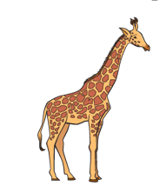

**Question 2. Nghe và tô màu (1 pt)**

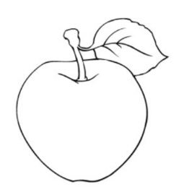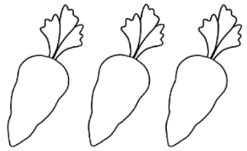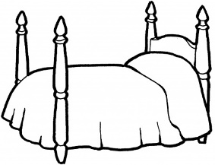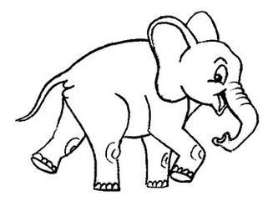

**Question 3. Nghe và nối (1 pt)**

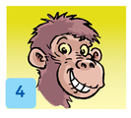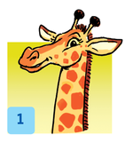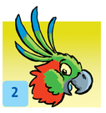

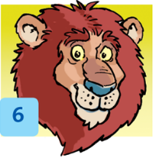

**Question 4. Nghe và đánh dấu tích (1 pt):**

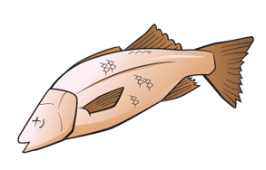Example:

1.

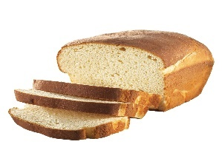Untitled-1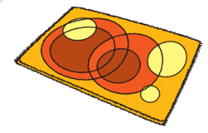



2. 3.



**4. 5.**

**Question 5. Nghe và điền từ vào chỗ chấm (1 pt)**

**coat**

1. This is his.................

Is he behind the door? No he isn’t.

1. Are you.....................?

We’re brother and sister. We’re cousins.

1. Billy, you like animals.

But you don’t like......................... and you don’t like giraffes.

1. Rice,............. and carrots for Billy.Do you like carrots, Billy?

No, I don’t. No carrots for me!

1. Look,Grandma. My.............. is tidy up now.

Good girl, Rosy. Well done!

**PART II: Reading and writing. (15 minutes)**

**Question 6**: Look and read. Put a tick (✓) on the right sentence and a cross (🗶) on the wrong sentence.

(Nhìn và đọc. Đánh dấu (vào câu đúng và dấu x vào câu sai)

Example:

It’s a circle. 🗹 It’s got four sides. 🗷



1. He has got short hair. □ 2. Thirteen □

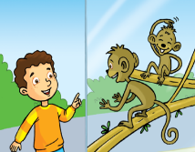

3. I like tigers □ 4. There is a blanket. □

**Question 7**: Look and read. Write “ Yes” on the right sentence and write “ No” on the wrong sentence.

(Nhìn và đọc. Viết Yes hay No vào chỗ trống)

Example:



She’s got long hair. Yes She’s got short hair. No



1. It’s got three sides. ________

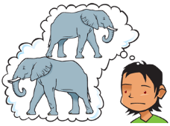

2. I don’t like giraffes. ________

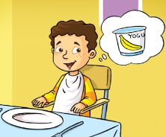

3. I like yogurt. ________

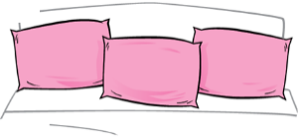

4. There are three pillows. ________

**Question 8**: Look at the picture. Look at the words. Write the sentences.

(Nhìn tranh. Nhìn các chữ cái, viết thành từ đúng)

Example:



.

got

a pen

I’ve

I’ve got a pen.



got

He’s

.

blond

hair

1. __________________________________



Do

like

?

parrots

you

2. ___________________________________

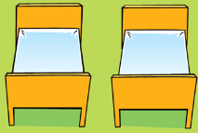

beds

two

.

are

There

3. _________________________________



I

.

ice cream

like

4. _________________________________

**Question 9**: Choose the right word/phrases from the box and write them next to numbers from 1 - 4.

(Chọn từ trong khung và điền vào chỗ trống)

milk tiger blanket curly hair carrot



Example:

0. carrot



1. _______________ 2. ________________

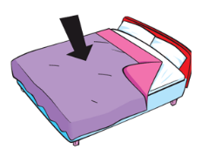

|  |  |
| --- | --- |
| **PHÒNG GD& ĐT**  **TRƯỜNG TIỂU HỌC…….** | **BÀI KIỂM TRA GIỮA HỌC KÌ I**  **Môn: Tiếng Anh 4 ( Thí điểm)**  **Thời gian: 45 phút**  **(Không kể thời gian giao đề)** |

**ĐỀ 15**

**PART 1. LISTENING ( 20 minutes)**

**Question 1: Listen and draw the line. There is an example. (1 pt)**

  

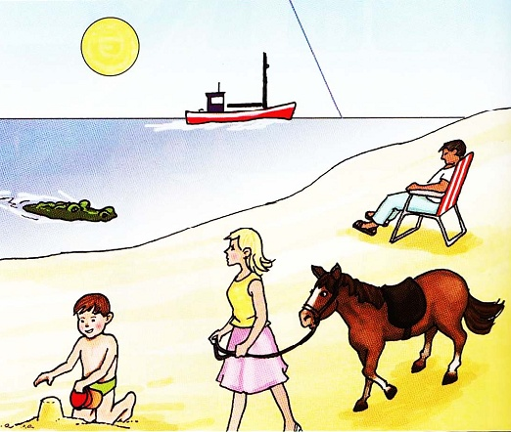



**Question 2: . Listen and number. (1 pt)**

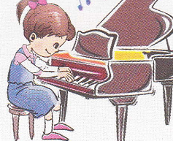 

 

**Question 3: Listen and tick. (1 pt). There is an example.**

***What’s Bill doing?***

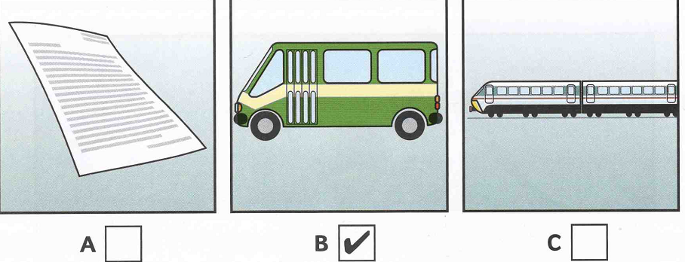

1. What’s Tom playing? 2. What’s Nick doing?

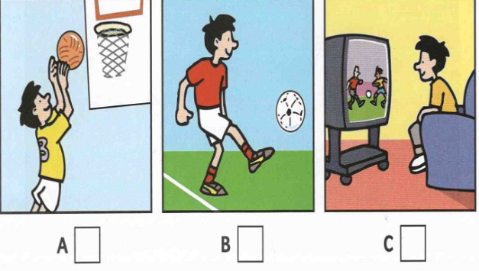 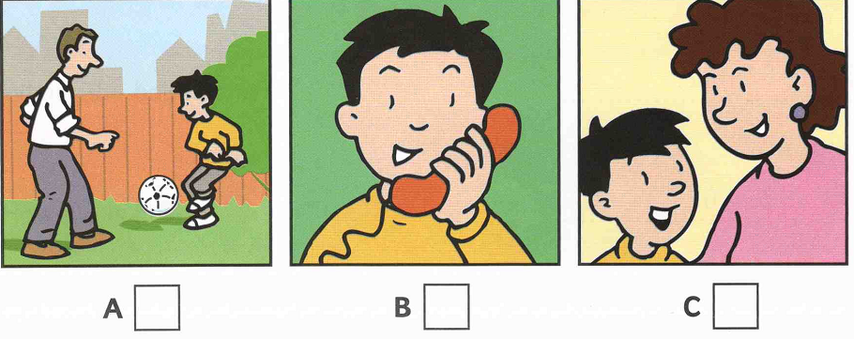

1. What’s Ben doing? 4. What’s Kim doing?

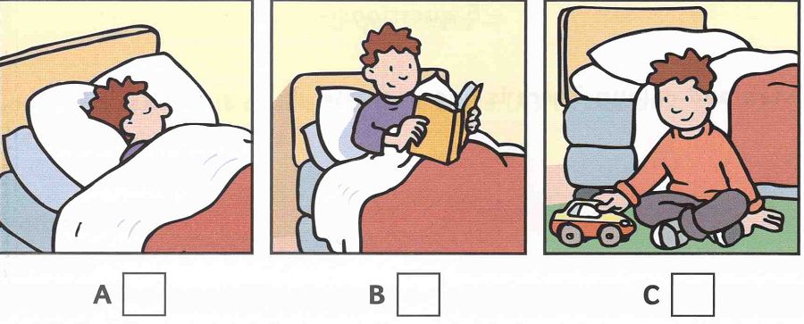 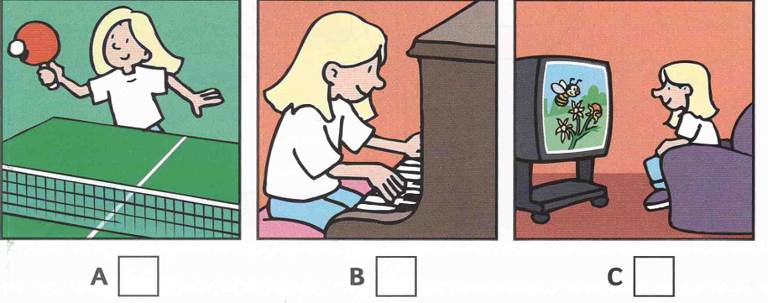

**Question 4: Listen and colour (1pt)**

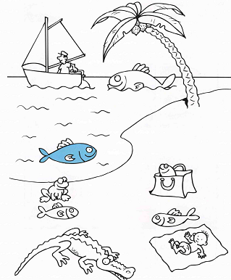

**Question 5: Listen and write a word or a number (1pt)**



***Examples:***

What’s the girl’s name ? ..............**Kim**.....................

How old is she? ..................**8**......................

***Questions:***

1. What’s the name of Kim’s father? ...........................................
2. Where does Kim live? in ................................street.
3. How many trees are there in Kim garden? ...........................................
4. Which school does Kim go to? ........................House School

**PART 2. READING AND WRITING ( 15 minutes)**

**Question 6: Look and read. Put a tick ( Description: MC900434665[1]) or a cross (****) in the box. (1 pt)**

 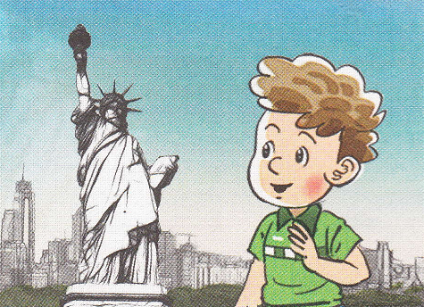

1. It’s the second of October 2. He’s American.

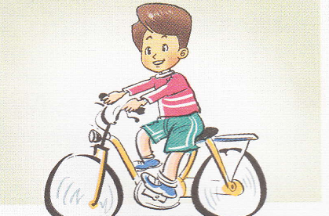 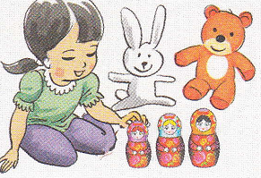

3. He can ride a bike 4. Her hobby is dancing.

**Question 7: Read and write suitable words in the gaps(1pt).**

1. She likes r _ ­­_ _ _ _ _ 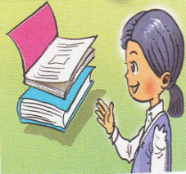 2. She is from J _ _ _ _ 

3. My birthday is in F _ _ _ _ _ _ _  4. I like c _ _ _ _ _ _ 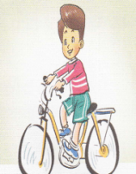

**Question 8: Look and read. Write Yes** *or* **No(1pt).**

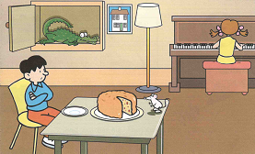

***Examples :*** There is a cake on the table ............Yes.................

The mouse is under the chair ............No..................

1. The boy is sitting at the table ....................................

2. There is an elephant in the cupboard ....................................

3. The girl is playing the piano ....................................

4. The lamp is between the cupboard and the picture ....................................

**Question 9: Fill in each gap from 1-5 with a suitable word from the box (1pt). There is an example.**



I am on a small .....**table**.... in the living room in Mr and Mrs’s Brown (1) _______ . The family sits on chairs or on their (2) _________ and watches me. They can watch sport like (3) ___________ or basketball or watch their favourite animals like (4) __________ on me. They watch me at (5) ___________ but not in the day. What I am? I am a television.

L4

house **table** football fish



sofa night pencils monkeys

_____________***____________________________________***

|  |  |
| --- | --- |
| **PHÒNG GD& ĐT**  **TRƯỜNG TIỂU HỌC…….** | **BÀI KIỂM TRA GIỮA HỌC KÌ I**  **Môn: Tiếng Anh 4 ( Thí điểm)**  **Thời gian: 45 phút**  **(Không kể thời gian giao đề)** |

**ĐỀ 16**

**I. Look and complete these words.**(Quan sát tranh và điền các chữ cái còn thiếu trong mỗi từ)

**la          ir         if         mi**

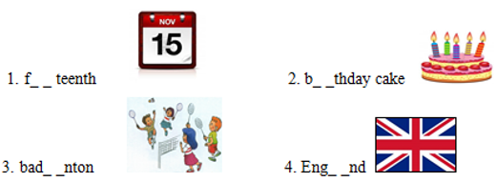

**II . Odd one out**(Khoanh tròn từ không cùng nhóm)

1. A. table tennis        B. badminton        C. guitar                D. volleyball

2. A. Vietnamese        B. England            C. Japan                 D. America

3. A. swim                 B. book                 C. cook                  D. skate

4. A. August               B. Sunday             C. July                   D. September

5. A. first                   B. third                 C. four                   D. second

**III. Choose the correct answer**(Chọn câu trả lời đúng)

1. Tony is from Australia. He is ....................................

A. Australia             B. Australias                 C. Autralian               D. Autralia

2. Hakim is fromMalaysia. .................................... nationality is Malaysian.

A.your                      B.our                          C.her                         D.his

3. What do you do…………….... Fridays? – I go to school in the morning.

A. in                         B. on                            C. at                        D. from

4. We have English on ………………………….

A. Mondays and Wednesdays

B. July and August

C. Mondays and September

D. November and December

5. My birthday is on the………. of October.

A.seven                      B.fifth                       C.eight                      D.five

**IV. Read and match**(Đọc và nối)

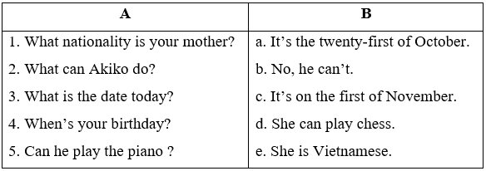

**V. Read and tick  True / False** (Đọc và đánh dấu đúng/ sai)

Dear penfriend,

My name’sNam. I’m from Thanh Hoa, Viet Nam.My school is Hai An Primary School. Today is the sixth of October. It’s my birthday. I’m happy. I have many birthday presents from my friends. We play hide – and – seek and sing a lot of Vietnamese songs together.What about you? When’s your birthday?

Write to me soon,

Nam.

1. Nam’s birthday is on the sixth of October.

2. His school is International School.

3. Nam is from Ha Noi.

4. They play hide-and-seek and sing a lot of Vietnamese songs together.

**VI. Write the answers**(Viết câu trả lời)

1. What day is it today?

2. What can you do?

|  |  |
| --- | --- |
| **PHÒNG GD& ĐT**  **TRƯỜNG TIỂU HỌC…….** | **BÀI KIỂM TRA GIỮA HỌC KÌ I**  **Môn: Tiếng Anh 4 ( Thí điểm)**  **Thời gian: 45 phút**  **(Không kể thời gian giao đề)** |

**ĐỀ 17**

**Exercise 1: Choose the odd one out**

1. A. park

B. rubber

A. pen

B. notebook

2. A. run

B. go

C. play

D. water

3. A. countryside

B. teacher

C. farmer

D. doctor

**Exercise 2: Choose the word whose underlined part is pronounced differently from the rest**

1. A. flats

B. days

C. jobs

D. chairs

2. A. school

B. chair

C. children

D. chick

**Exercise 3: Choose the correct answer**

1. The boys ______ paper planes now

A. are doing

B. does

C. are making

D. makes

2. Yesterday morning, he _________ his friends on the Internet

A. chat with

B. chatted with

C. chat to

D. chatted to

3. _________ birthday is this today? - It’s ___________.

A. Whose/ my brother

B. Whose/ my brother’s

C. Who/ my brother

D. Whom/ my brother’s

4. It’s _________ at school and the students are in the playground.

A. broken time

B. break time

C. full time

D. part time

5. They study Maths ________ Monday ________ Friday

A. from - to

B. from - on

C. on - on

D. on - to

6. I ________ television before I went to bed last night

A. listened to

B. watched

C. read

D. played

7. Can you _______ a bike?

A. ride

B. skate

C. skip

D. dance

8. They _______ in their room all day.

A. did

B. did be

C. was

D. weren’t

**Exercise 4: Read the following text and choose the best answer**

Here is Brandon. He goes to London Primary School. He is in class 4A. This is his classroom. There are fifteen boys and ten girls in his class. His best friend is Lucas. Thay both enjoy Geography. They have it on Thursdays and Fridays. On Saturdays and Sundays, they don’t have to go to school. They often play soccer together. Yesterday was Sunday. They played football in a playground near his house.

1. Which school does Brandon go to?

A. Brandon studies at Primary School

B. Brandon goes to Primary School

C. Brandon studies at London Primary School

D. Brandon is going to Primary School

2. How many boys and girls are in his class?

A. Fifth boys and ten girls

B. Five boys and tenth girls

C. Fifteen boys and ten girls

D. Fifty boys and ten girls

3. Who is his best friend?

A. Brandon

B. Lucas

C. Geography

D. Primary

4. Do they have to go to school on Saturdays and Sundays?

A. Not

B. No, they aren’t

C. Yes, they do

D. No, they don’t

5. Where did they play football yesterday?

A. In a playground near his house

B. In the school ground

C. In the stadium

D. Near the library

**Exercise 5: Reorder these words to have correct sentences**

1. her/ dance/ beautifully/ can/ sister/ ./

________________________________________________

2. school/ my/ big/ is/ a/ city/ in/ ./

________________________________________________

3. I/ evening/ TV/ watched/ yesterday/ ./

________________________________________________

4. what/ yesterday/ did/ they/ do/ ?/

________________________________________________

|  |  |
| --- | --- |
| **PHÒNG GD& ĐT**  **TRƯỜNG TIỂU HỌC…….** | **BÀI KIỂM TRA GIỮA HỌC KÌ I**  **Môn: Tiếng Anh 4 ( Thí điểm)**  **Thời gian: 45 phút**  **(Không kể thời gian giao đề)** |

**ĐỀ 18**

**Exercise 1: Listen and circle the correct answer**

1. He is playing __________ with his friends
2. badminton
3. football
4. volleyball
5. James can ___________ beautiful pictures
6. run
7. make
8. draw
9. We are making paper __________ now
10. cars
11. planes
12. houses
13. The children like _________ videos on YouTube very much
14. playing
15. watching
16. making
17. My father can ____________ but I can’t do it
18. fly a plane
19. write a letter
20. drive a car

**Exercise 2: Choose the odd one out**

|  |  |  |  |
| --- | --- | --- | --- |
| 1. A. park | 1. rubber | 1. pen | 1. notebook |
| 1. A. listening | 1. watching | 1. playing | 1. school |
| 1. A. photos | 1. pictures | 1. shopping | 1. stamps |

**Exercise 3: Choose the word whose underlined part is pronounced differently from the rest**

|  |  |  |  |
| --- | --- | --- | --- |
| 1. A. subjects | 1. masks | 1. cats | 1. swims |
| 1. A. listened | 1. watched | 1. stopped | 1. laughed |

**Exercise 4: Choose the correct answer**

1. I was at school. What ________ you?
2. with
3. about
4. How
5. are
6. What is the name ______ your school, Tom?
7. of
8. in
9. with
10. at
11. Yesterday morning, he _______ his friends on the Internet
12. chat with
13. chatted with
14. chat to
15. chatted to
16. The boys ________ paper planes now
17. are doing
18. does
19. are making
20. makes
21. Twenty - The twentieth, Thirty - __________.
22. The thirty
23. The thirtyth
24. The thirtieth
25. The thirteenth

**Exercise 5: Read the following the text and choose True (T) or False (F)**

Yesterday was Sunday. So I didn’t go to school. I went to the zoo with my sister in the afternoon. We saw many animals there such as bears, giraffes, lions and tigers. After that, we went to a restaurant to have dinner. We had a big pizza and spaghetti. We drank fresh cola. Then we went home at 9 p.m. What a wonderful day!

1. Yesterday was Monday
2. They saw bears and lions
3. They had dinner at home
4. They had a small pizza
5. They had fresh cola

**Exercise 6: Reorder the words to make meaningful sentences**

1. What/ yesterday/ did/ do/ they/ ?

__________________________________________________

1. My/ not/ brother/ in/ his/ listening/ room/ is/ to/ music/ now/ ./

__________________________________________________

1. you/ have/ When/ do/ Science/ ?/

__________________________________________________

1. Her/ dance/ beautifully/ can/ sister/ ./

__________________________________________________

1. classmates/ They/ are

__________________________________________________

|  |  |
| --- | --- |
| **PHÒNG GD& ĐT**  **TRƯỜNG TIỂU HỌC…….** | **BÀI KIỂM TRA GIỮA HỌC KÌ I**  **Môn: Tiếng Anh 4 ( Thí điểm)**  **Thời gian: 45 phút**  **(Không kể thời gian giao đề)** |

**ĐỀ 19**

**Exercise 1: Listen and circle the correct answer**

1. The _______ is reading books in the library
2. teacher
3. farmer
4. doctor
5. Tony and Phong are playing _________ in the yard
6. volleyball
7. badminton
8. Art
9. Mary likes learning _________ because she wants to be a singer
10. Maths
11. Music
12. Art
13. When do you have ________? - I have it every day
14. Vietnamese
15. Maths
16. Science
17. There is a _______ near my school.
18. cinema
19. museum
20. post office

**Exercise 2: Choose the odd one out**

|  |  |  |  |
| --- | --- | --- | --- |
| 1. A. park | 1. rubber | 1. pen | 1. notebook |
| 1. A. countryside | 1. teacher | 1. farmer | 1. doctor |
| 1. A. run | 1. go | 1. play | 1. water |

**Exercise 3: Choose the word whose underlined part is pronounced differently from the rest**

|  |  |  |  |
| --- | --- | --- | --- |
| 1. A. country | 1. my | 1. sky | 1. dry |
| 1. A. pen | 1. desk | 1. children | 1. spell |

**Exercise 4: Choose the correct answer**

1. Where are your friends from? - They are from __________.
2. Korean
3. English
4. Vietnam
5. Chinese
6. I _______ early in the morning.
7. get up
8. have
9. get
10. am
11. How many _____ are there in a year?
12. days
13. day
14. month
15. months
16. What subjects _______ you __________ today?
17. do - haves
18. do -have
19. do -has
20. does -has
21. __________ the picture? - It’s on the wall
22. What
23. Where
24. Where’s
25. Where’ re
26. I usually read a book _______ the evening
27. on
28. at
29. with
30. in

**Exercise 5: Correct the mistakes**

1. The students is writing a dictation at the moment

____________________________________________

1. Are they have an Art lesson right now? - Yes, they are

____________________________________________

1. Where were he?

____________________________________________

**Exercise 6: Read the following text and answer the following questions**

Last night, my family were at home. We did lots of things. My father listened to the news on TV. My mom watched a famous film on her phone. My grandparents sat in front of a fireplace and talked to each other. My older brother and I studied in our room. We all went to bed at 10 p.m.

1. Where were they last night?

____________________________________________

1. What did his father do?

____________________________________________

1. What did his mother do?

____________________________________________

1. Where did his grandparents sit?

____________________________________________

1. What time did they go to bed?

____________________________________________

**Exercise 7: Reorder these words to make meaningful sentences**

1. were/ Where/ yesterday/ you/ ?/

____________________________________________

1. I/ on/ the/ was/ at/ Ha Long/ beach/ Bay/ ./

____________________________________________

1. a/ I/ want/ penfriend/ really/ ./

____________________________________________

|  |  |
| --- | --- |
| **PHÒNG GD& ĐT**  **TRƯỜNG TIỂU HỌC…….** | **BÀI KIỂM TRA GIỮA HỌC KÌ I**  **Môn: Tiếng Anh 4 ( Thí điểm)**  **Thời gian: 45 phút**  **(Không kể thời gian giao đề)** |

**ĐỀ 20**

**Phần 1: Pick the right answer (Chọn đáp án đúng cho mỗi câu hỏi dưới đây)**

1. Where _____ you from? I am from Vietnam.

A. is B. be C. am D. are

2. There _____ twenty students in my class.

A. is B. am C. are D. don't

3. A: Hi! My name is Tuan

B: I am Minh. Nice to meet _____.

A. you B. his C. her D. she

4. Choose the odd one out.

A. cat B. dog C. house D. cow

5. My brother _____ 5 years old.

A. am B. is C. are D. be

6. Choose the odd one out.

A. soccer B. Physics C. Music D. Maths

7. Tuan is my _____ too.

A. he B. she C. friend D. be

8. We do many exercises ______ Math lessons.

A. to B. so C. during D. but

9. Is ______ house big?

A. you B. your C. yours D. yous

10. Tuan is _____ neighbour.

A. he B. him C. they D. his

**Phần 2: Fill the blank (Điền từ/ chữ cái còn thiếu vào chỗ trống)**

11. Do you want a cup of coffee? _ _, I am not.

12. A ch_ _ken

13. Stand _ _, please.

14. _ _ose are my notebooks.

15. A. Where is Tuan from?

B: _ _ is from Thailand.

16. home w_ _k

17. This is my h_use.

18. suns_ _ne

19. There are twenty chairs _ _ my classroom.

20. I _ _ _ swim but I can't dive.

**Phần 3: Cool pair matching (Nối từ Tiếng Anh với định nghĩa Tiếng Việt tương ứng)**

21. Pencil A. Quả táo

22. Apple B. Cái giường

23. Bed C. Cái bàn

24. Table D. Ngôi nhà

25. Cat E. Con Mèo

26. House F. Bút chì