**Ma trận đề thi giữa học kì tiếng anh lớp 4**

|  |  |  |  |  |  |  |
| --- | --- | --- | --- | --- | --- | --- |
| Kĩ năng | Nhiệm vụ đánh giá/ kiến thức cần đánh giá | Mức/ Điểm | | | | Tổng số câu,số điểm, tỉ lệ % |
| M1 | M2 | M3 | M4 |
| Nghe | **Listen and tick** |  | 1  0,25 đ | 2  0,5 đ |  | 12 câu  3 điểm  30% |
| **Listen and number** |  |  | 3  0,75 đ |  |
| **Listen and match** |  |  | 3  0,75 đ |  |
| **Listen and complete** |  |  | 2  0,5 đ | 1  0,25 đ |

**LISTENING**

|  |  |  |  |  |  |  |
| --- | --- | --- | --- | --- | --- | --- |
| **Kĩ năng** | **Kiến thức cần đánh giá** | **M1** | **M2** | **M3** | **M4** | **Tổng số câu. Điểm tỉ lệ %** |
| Đọc | **Look and read** | 1  0, 25 | 2  0, 5 |  |  | 10 câu  2,5 điểm  25 % |
|  | **Read and complete** |  | 3  0, 75 | 1  0, 25 |  |
|  | **Read and tick True or False** |  | 1  0, 25 | 1  0, 25 | 1  0, 25 |

**READING**

**WRITING**

|  |  |  |  |  |  |  |
| --- | --- | --- | --- | --- | --- | --- |
| **Kỹ năng** | **Nhiệm vụ đánh giá / kiến thức cần đánh giá** | **Mức / Điểm** | | | | **Tổng số câu, số điểm,**  **tỷ lệ %** |
| **M1** | **M2** | **M3** | **M4** |
| **Viết** | **Read and write ONE word in each gap for each picture** |  | 4  1,0đ |  |  | 10 câu  2,5 điểm  25% |
| **Read and complete a sentence with ONE word.** |  |  | 1  0,25đ |  |
| **Order the word** | 2  0,5đ | 2  0,5đ | 1  0,25đ |  |

|  |  |
| --- | --- |
| **PHÒNG GD& ĐT**  **TRƯỜNG TIỂU HỌC…….** | **BÀI KIỂM TRA GIỮA HỌC KÌ I**  **Môn: Tiếng Anh 4 ( Thí điểm)**  **Thời gian: 45 phút**  **(Không kể thời gian giao đề)** |

**Đề 1**

***Exercise 1: Chọn từ khác loại***

1. A. Math B. Name C. English D. Vietnamese

2. A. Where B. What C. Why D. Can

3. A. Country B. Singapore C. China D. Australia

4. A. Cook B. Play C. Go D. Would

5. A. Birthday B. Monday C. Friday D. Thursday

6. A. Was B. Am C. Is D. Are

7. A. On B. To C. Be D. For

8. A. Japanese B. America C. Cambodia D. Malaysia

***Exercise 2: Cho dạng đúng của các động từ sau***

1. He can (climb) \_\_\_\_\_\_\_\_\_\_\_\_\_\_\_\_\_ the trees.

2. When (be) \_\_\_\_\_\_\_\_\_\_\_\_\_\_\_\_\_ your birthday?

3. I (stay) \_\_\_\_\_\_\_\_\_\_\_\_\_\_\_\_\_ at home yesterday.

4. What \_\_\_\_\_\_\_\_\_\_\_\_\_\_ they (do) \_\_\_\_\_\_\_\_\_\_\_\_\_\_ now?

5. They (play) \_\_\_\_\_\_\_\_\_\_\_\_\_\_\_\_\_ the piano now.

6. Today she (have) \_\_\_\_\_\_\_\_\_\_\_\_\_\_\_\_\_ English and history.

7. What day (be) \_\_\_\_\_\_\_\_\_\_\_\_\_\_\_\_\_ it today?

8. Tommy and Vicky (be) \_\_\_\_\_\_\_\_\_\_\_\_\_\_\_\_\_ from Korea.

***Exercise 3: Nối câu hỏi ở cột A với câu trả lời thích hợp ở cột B***

|  |  |
| --- | --- |
| **A** | **B** |
| 1. What is Mr. Long doing?  2. When is his birthday?  3. Where are you from?  4. Where were you yesterday?  5. Can he cook?  6. What is Hanna’s nationality?  7. What do they have on Wednesday?  8. What do you like doing? | a, Yes, he can.  b, I am from Vietnam.  c, I like dancing and singing.  d, His birthday is in October.  e, She is Japanese.  f, I was at home yesterday.  g, He is teaching a lesson.  h, They have Math and PE. |

***Exercise 4: Hoàn thành hội thoại dựa vào các từ cho trước***

|  |
| --- |
| **do name What an too** |

Bob: Hi. I’m Bob. What’s your (1) \_\_\_\_\_\_\_\_\_\_\_?

Clara: My name is Clara. Nice to meet you.

Bob: Nice to meet you, (2) \_\_\_\_\_\_\_\_\_\_\_.

Clara: What is your nationality?

Bob: I’m American. (3) \_\_\_\_\_\_\_\_\_\_\_ about you?

Clara: I’m English. Can you sing (4) \_\_\_\_\_\_\_\_\_\_\_ English song?

Bob: Yes, I can. I can sing and dance. Do you like playing the guitar?

Clara: Yes, I (5) \_\_\_\_\_\_\_\_\_\_\_. I want to learn to play it.

Bob: I can teach you.

Clara: That’s great.

***Exercise 5: Sắp xếp các từ để tạo thành câu hoàn chỉnh***

1. you/ subjects/ today/ What/ have/ do?

\_\_\_\_\_\_\_\_\_\_\_\_\_\_\_\_\_\_\_\_\_\_\_\_\_\_\_\_\_\_\_\_\_\_\_\_\_\_\_\_\_\_\_\_\_\_\_\_\_\_\_?

2. Can/ football/ you/ play?

\_\_\_\_\_\_\_\_\_\_\_\_\_\_\_\_\_\_\_\_\_\_\_\_\_\_\_\_\_\_\_\_\_\_\_\_\_\_\_\_\_\_\_\_\_\_\_\_\_\_\_?

3. email/ an/ I/ writing/ am.

\_\_\_\_\_\_\_\_\_\_\_\_\_\_\_\_\_\_\_\_\_\_\_\_\_\_\_\_\_\_\_\_\_\_\_\_\_\_\_\_\_\_\_\_\_\_\_\_\_\_\_.

4. She/ very/ cooking/ much/ likes.

\_\_\_\_\_\_\_\_\_\_\_\_\_\_\_\_\_\_\_\_\_\_\_\_\_\_\_\_\_\_\_\_\_\_\_\_\_\_\_\_\_\_\_\_\_\_\_\_\_\_\_.

|  |  |
| --- | --- |
| **PHÒNG GD& ĐT**  **TRƯỜNG TIỂU HỌC…….** | **BÀI KIỂM TRA GIỮA HỌC KÌ I**  **Môn: Tiếng Anh 4 ( Thí điểm)**  **Thời gian: 45 phút**  **(Không kể thời gian giao đề)** |

**ĐỀ 2**

***Exercise 1: Chọn từ có cách phát âm khác với các từ còn lại***

1. A. pupil B. music C. sun D. student

2. A. football B. book C. good D. food

3. A. Monday B. come C. from D. some

4. A. skate B. can C. may D. date

***Exercise 2: Điền chữ cái thích hợp vào chỗ trống***

1. It’s n\_ce t\_ meet \_ou.

2. I’m a p\_p\_ \_.

3. W\_ere a\_ \_ you f\_om?

4. T\_ \_ay is S\_nd\_y.

5. Tha\_ \_ you very \_uch.

6. My b\_ thday is in Fe\_ \_uary.

***Exercise 3: Sắp xếp các câu sau thành đoạn hội thoại hoàn chỉnh***

🞎 Hi. It’s nice to see you. I’m from England. But I live in Hanoi now.

🞎 Nice to meet you, Tom. Where are you from?

🞎 Yes, I am. I love learning Vietnamese.

🞎 No, I can’t speak it fluently.

🞎 Oh I’m in Hanoi, too. Are you a pupil?

🞎 Hey, Anna. This is my friend, Tom.

🞎 Wow! Can you speak Vietnamese?

***Exercise 4: Dựa vào tranh và hoàn thành câu***

1. He comes from \_\_\_\_\_\_\_\_\_\_\_\_\_\_. 

2. I cannot \_\_\_\_\_\_\_\_\_\_\_\_. 

3. My birthday is \_\_\_\_\_\_\_\_\_\_\_ March. 

4. I go to Quang Trung \_\_\_\_\_\_\_\_\_\_\_\_ school. 

***Exercise 5: Sắp xếp các từ sau thành câu hoàn chỉnh***

1. you/ What/ nationality/ are?

\_\_\_\_\_\_\_\_\_\_\_\_\_\_\_\_\_\_\_\_\_\_\_\_\_\_\_\_\_\_\_\_\_\_\_\_\_\_\_\_\_\_\_\_\_\_\_\_\_\_\_\_\_\_\_\_\_\_\_.

2. have/ They/ Tuesday/ Math/ on.

\_\_\_\_\_\_\_\_\_\_\_\_\_\_\_\_\_\_\_\_\_\_\_\_\_\_\_\_\_\_\_\_\_\_\_\_\_\_\_\_\_\_\_\_\_\_\_\_\_\_\_\_\_\_\_\_\_\_\_.

3. play/ She/ cannot/ baseball.

\_\_\_\_\_\_\_\_\_\_\_\_\_\_\_\_\_\_\_\_\_\_\_\_\_\_\_\_\_\_\_\_\_\_\_\_\_\_\_\_\_\_\_\_\_\_\_\_\_\_\_\_\_\_\_\_\_\_\_.

4. it/ day/ What/ today/ is/?

\_\_\_\_\_\_\_\_\_\_\_\_\_\_\_\_\_\_\_\_\_\_\_\_\_\_\_\_\_\_\_\_\_\_\_\_\_\_\_\_\_\_\_\_\_\_\_\_\_\_\_\_\_\_\_\_\_\_\_.

|  |  |
| --- | --- |
| **PHÒNG GD& ĐT**  **TRƯỜNG TIỂU HỌC…….** | **BÀI KIỂM TRA GIỮA HỌC KÌ I**  **Môn: Tiếng Anh 4 ( Thí điểm)**  **Thời gian: 45 phút**  **(Không kể thời gian giao đề)** |

**ĐỀ 3**

***Exercise 1: Viết các tháng trong năm theo đúng thứ tự***

**MAY DECEMBER JUNE**

**FEBRUARY OCTOBER APRIL**

**MARCH JULY SEPTEMBER**

**JANUARY AUGUST NOVEMBER**

1. \_\_\_\_\_\_\_\_\_\_\_\_\_\_\_\_ 7. \_\_\_\_\_\_\_\_\_\_\_\_\_\_\_\_

2. \_\_\_\_\_\_\_\_\_\_\_\_\_\_\_\_ 8. \_\_\_\_\_\_\_\_\_\_\_\_\_\_\_\_

3. \_\_\_\_\_\_\_\_\_\_\_\_\_\_\_\_ 9. \_\_\_\_\_\_\_\_\_\_\_\_\_\_\_\_

4. \_\_\_\_\_\_\_\_\_\_\_\_\_\_\_\_ 10. \_\_\_\_\_\_\_\_\_\_\_\_\_\_\_

5. \_\_\_\_\_\_\_\_\_\_\_\_\_\_\_\_ 11. \_\_\_\_\_\_\_\_\_\_\_\_\_\_\_

6. \_\_\_\_\_\_\_\_\_\_\_\_\_\_\_\_ 12. \_\_\_\_\_\_\_\_\_\_\_\_\_\_\_

***Exercise 2: Chọn từ khác loại***

1. A. ski B. skip C. school D. skate

2. A. he B. her C. you D. they

3. A. flag B. Malaysia C. Singapore D. China

4. A. nice B. name C. class D. pupil

***Exercise 3: Gạch chân lỗi sai và sửa lại cho đúng***

1. What is your birthday? \_\_\_\_\_\_\_\_\_\_\_\_\_\_\_\_\_\_

2. What is she name? \_\_\_\_\_\_\_\_\_\_\_\_\_\_\_\_\_\_

3. I don’t go to school at Sunday. \_\_\_\_\_\_\_\_\_\_\_\_\_\_\_\_\_\_

4. Tom have an Art class today. \_\_\_\_\_\_\_\_\_\_\_\_\_\_\_\_\_\_

***Exercise 4: Chọn đáp án đúng***

1. Where are you from, Tom? \_\_\_\_\_\_\_\_\_\_ from America.

A. I am          B. My name         C. You are          D. Her name

2. Hello, my \_\_\_\_\_\_\_\_\_\_ is Mary.

A. name         B. name’s          C. named           D. names

3. This \_\_\_\_\_\_ my friend, Linda. She is from England.

A. is           B. are           C. was          D. were

4. \_\_\_\_\_\_\_\_ is the date today?

A. Where          B. What          C. When        D. How

5. \_\_\_\_\_\_\_\_\_to meet you, too.

A. Fine          B. She         C. They D. Nice

6. Where are you from?

A. I’m from Malaysia.           C. I’m an Japanese.

B. I from Japan.         D. I Malaysian.

7. .................. you sing? ................., I can.

A. Can/ No        B. Cannot/ Yes         C. Can/ Yes           D. Can/ Not

8. My birthday is on the .................. of October.

A. Thursday         B. two           C. ten           D. fifth

***Exercise 5: Viết 1 đoạn văn ngắn từ 3-5 câu về bản thân em***

***Gợi ý:***

- What’s your name?

- How old are you?

- When is your birthday?

- What subject do you like?

- What can you do?

\_\_\_\_\_\_\_\_\_\_\_\_\_\_\_\_\_\_\_\_\_\_\_\_\_\_\_\_\_\_\_\_\_\_\_\_\_\_\_\_\_\_\_\_\_\_\_\_\_\_\_\_\_\_\_\_\_\_\_\_\_\_\_\_\_\_\_\_\_\_\_\_\_\_\_\_\_\_\_\_\_\_\_\_\_\_\_\_\_\_\_\_\_\_\_\_\_\_\_\_\_\_\_\_\_\_\_\_\_\_\_\_\_\_\_\_\_\_\_\_\_\_\_\_\_\_\_\_\_\_\_\_\_\_\_\_\_\_\_\_\_\_\_\_\_\_\_\_\_\_\_\_\_\_\_\_\_\_\_\_\_\_\_\_\_\_\_\_\_\_\_\_\_\_\_\_\_\_\_\_\_\_\_\_\_\_\_\_\_\_\_\_\_\_\_\_\_\_\_\_\_\_\_\_\_\_\_\_\_\_\_\_\_\_\_\_\_\_\_\_\_\_\_\_\_\_\_\_\_\_\_\_\_\_\_\_\_\_\_\_\_\_\_\_\_\_\_\_\_\_\_\_\_\_\_\_\_\_\_\_\_\_\_\_\_\_\_\_\_\_\_\_\_\_\_\_\_\_\_\_\_\_\_\_\_\_\_\_\_\_\_\_\_\_\_\_\_\_\_\_\_\_\_\_\_\_\_\_\_\_\_\_\_\_\_\_\_\_\_\_\_\_\_\_\_\_\_\_\_\_\_\_\_\_\_\_\_\_\_\_\_\_\_\_\_\_\_\_\_\_\_\_\_\_\_\_\_\_\_\_\_\_\_\_\_\_\_\_\_\_\_\_\_\_\_\_\_\_\_\_\_\_\_\_\_\_\_\_\_\_\_\_\_\_\_\_\_\_\_\_\_\_\_\_\_\_\_\_\_\_\_\_\_\_\_\_\_\_\_\_\_\_\_\_\_\_\_\_\_\_\_\_

|  |  |
| --- | --- |
| **PHÒNG GD& ĐT**  **TRƯỜNG TIỂU HỌC…….** | **BÀI KIỂM TRA GIỮA HỌC KÌ I**  **Môn: Tiếng Anh 4 ( Thí điểm)**  **Thời gian: 45 phút**  **(Không kể thời gian giao đề)** |

**ĐỀ 4**

**Question 1: Chọn từ có cách phát âm khác với các từ còn lại**

1. A. birthday B. play C. Japanese D. today

2. A. thin B. slim C. music D. five

3. A. mouse B. blouse C. cloud D. trousers

4. A. number B. student C. much D. cupboard

**Question 2: Chọn đáp án đúng**

1. What \_\_\_\_\_\_\_\_\_\_\_ your nationality?

A. be B. is C. are D. was

2. How \_\_\_\_\_\_\_\_\_\_\_ is your sister?

A. old B. much C. often D. long

3. \_\_\_\_\_\_\_\_\_\_\_ do you have IT lesson?

A, How B. What C. Where D. When

4. – \_\_\_\_\_\_\_\_\_\_\_ his mother a dentist? – Yes, she is.

A. Does B. Will C. Can D. Is

5. What day is \_\_\_\_\_\_\_\_\_\_\_ today?

A. they B. he C. it D. you

6. My school is \_\_\_\_\_\_\_\_\_\_\_ Nguyen Hoang street.

A. to B. in C. with D. of

**Question 3: Nối cột A với cột B**

|  |  |
| --- | --- |
| **A** | **B** |
| 1. Can you sing an English song?  2. What day is it today?  3. Is he 2 years younger than his brother?  4. Nice to meet you.  5. What does his mother do?  6. What do you like doing? | a. It’s Tuesday.  b. Nice to meet you, too.  c. Yes, I can.  d. I like dancing.  e. No, he is three years younger.  f. She is a housewife. |

**Question 4: Đọc đoạn văn và viết T (true) vào câu đúng, F (false) vào câu sai**

Hi. My name is Mary. I’m twelve years old. I’m a pupil. I live in a beautiful area in a big city. Every morning I get up at 5:30 o’ clock. After that, I dress up at 6. I have breakfast in ten minutes and go to school at half past six. My school is near my house so I often go to school on foot. I love English so much. I can read English books and sing some English songs.

**TRUE or FALSE?**

1. Mary is 12 years old. \_\_\_\_\_\_\_\_\_\_\_\_\_\_

2. She gets up at half past six. \_\_\_\_\_\_\_\_\_\_\_\_\_\_

3. She goes to school on foot at 6:30. \_\_\_\_\_\_\_\_\_\_\_\_\_\_

4. She can write English songs. \_\_\_\_\_\_\_\_\_\_\_\_\_\_

**Question 5: Sắp xếp các từ thành câu hoàn chỉnh**

1. you/ subject/ like/ What/ do?

\_\_\_\_\_\_\_\_\_\_\_\_\_\_\_\_\_\_\_\_\_\_\_\_\_\_\_\_\_\_\_\_\_\_\_\_\_\_\_\_\_\_?

2. February/ My/ in/ is/ birthday?

\_\_\_\_\_\_\_\_\_\_\_\_\_\_\_\_\_\_\_\_\_\_\_\_\_\_\_\_\_\_\_\_\_\_\_\_\_\_\_\_\_\_.

3. very/ thank/ I’m/ you/ well.

\_\_\_\_\_\_\_\_\_\_\_\_\_\_\_\_\_\_\_\_\_\_\_\_\_\_\_\_\_\_\_\_\_\_\_\_\_\_\_\_\_\_.

4. Sandy/ now/ classroom/ in/ is/ the.

\_\_\_\_\_\_\_\_\_\_\_\_\_\_\_\_\_\_\_\_\_\_\_\_\_\_\_\_\_\_\_\_\_\_\_\_\_\_\_\_\_\_.

|  |  |
| --- | --- |
| **PHÒNG GD& ĐT**  **TRƯỜNG TIỂU HỌC…….** | **BÀI KIỂM TRA GIỮA HỌC KÌ I**  **Môn: Tiếng Anh 4 ( Thí điểm)**  **Thời gian: 45 phút**  **(Không kể thời gian giao đề)** |

**ĐỀ 5**

***Question 1: Chọn từ có cách phát âm khác với các từ còn lại***

1. A. Friday B. fine C. listen D. light

2. A. paper B. watch C. date D. plane

3. A. home B. hobby C. volleyball D. October

4. A. room B. cool C. school D. book

***Question 2: Chọn đáp án đúng***

1. Tony is from Australia. He is ....................................

A. Australia B. Australias C. Australian D. Australist

2. Hakim is from Malaysia. .................................... nationality is Malaysian.

A. your B. our C. her D. his

3. What do you do ……….. Fridays? – I go to school in the morning.

A. in B. on C. at D. from

4. We have English on ………………………….

A. Mondays and Wednesdays

B. July and August

C. Mondays and September

D. November and December

5. What ………………. do you have today?

A. favourite B. district C. Maths D. subjects

6. ………… is your English teacher?

A. What B. How C. When D. Who

7. Where ……….. you this yesterday?

A. were B. was C. is D. are

8. I live ………………. Phu Quoc Island?

A. in B. on C. to D. at

***Question 3: Đọc đoạn văn, viết YES ở câu đúng là No ở câu sai***

Alex is a pupil at Sunflower Primary School. It is a big school in London. His school is in Sutton Street. There are many classrooms. They are beautiful. There is a library, a music room and a computer room. He loves his school.

1. His name is Alex.        ...........................................

2. His school is small. ...........................................

3. His school is in Hanoi.  ...........................................

4. He loves his school.      ...........................................

***Question 4: Chọn từ thích hợp để điền vào chỗ trống***

|  |  |  |  |  |
| --- | --- | --- | --- | --- |
| **primary** | **sing** | **November** | **Vietnam** | **name** |

Hi. My (1) \_\_\_\_\_\_\_\_\_\_\_ is Nam. I’m from (2) \_\_\_\_\_\_\_\_\_\_\_\_\_. I’m 11 years old. My birthday is on the third of (3) \_\_\_\_\_\_\_\_\_\_\_\_. I study at Le Hong Phong (4) \_\_\_\_\_\_\_\_\_\_\_\_\_ school. I like Music very much. In my free time, I go to Music club. I can (5) \_\_\_\_\_\_\_\_\_\_\_\_\_\_ but I can’t play the violin.

***Question 5: Sắp xếp các chữ cái để tạo thành từ đúng dựa vào tranh***

1. APION \_\_\_\_\_\_\_\_\_\_\_\_\_\_\_\_\_\_\_\_ 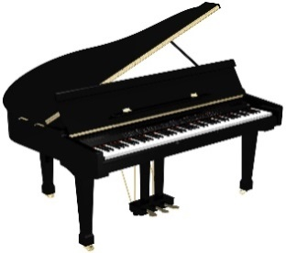

2. WREFLO \_\_\_\_\_\_\_\_\_\_\_\_\_\_\_\_\_\_\_\_ 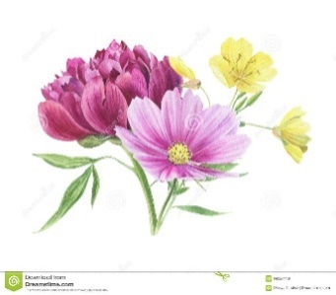

3. UMSCI \_\_\_\_\_\_\_\_\_\_\_\_\_\_\_\_\_\_\_\_ 

4. NTENSI \_\_\_\_\_\_\_\_\_\_\_\_\_\_\_\_\_\_\_\_ 

|  |  |
| --- | --- |
| **PHÒNG GD& ĐT**  **TRƯỜNG TIỂU HỌC…….** | **BÀI KIỂM TRA GIỮA HỌC KÌ I**  **Môn: Tiếng Anh 4 ( Thí điểm)**  **Thời gian: 45 phút**  **(Không kể thời gian giao đề)** |

**ĐỀ 6**

***Question 1: Chọn từ có cách phát âm khác với các từ còn lại***

1. A. music B. district C. city D. fire

2. A. walk B. class C. glasses D. badminton

3. A. student B. study C. much D. umbrella

4. A. name B. same C. game D. lamp

***Question 2: Chọn đáp án đúng***

1. Sandra likes \_\_\_\_\_\_\_\_\_\_\_ to music.

A. listening B. listen C. to listen D. listen

2. He can play football \_\_\_\_\_\_\_ he can’t play table tennis.

A. because B. and C. but D. when

3. Where is she \_\_\_\_\_\_\_? – She’s from Japan.

A. in B. from C. at D. on

4. Where \_\_\_\_\_\_\_ you yesterday?

A. is B. are C. was D. were

5. What \_\_\_\_\_\_\_does Mai have today? – She has Math, Music, Science and English.

A. class B. subjects C. time D. nationality

6. \_\_\_\_\_\_\_ day is it today? –It’s Monday.

A. Why B. What C. When D. How

***Question 3: Đọc đoạn văn và chọn đáp án đúng điền vào chỗ trống***

This is my mother. (1)\_\_\_\_\_\_\_\_\_ name is Hien. She is a teacher. She gets up at 5:30 in the morning. She has (2)\_\_\_\_\_\_\_\_\_ at 6 o’clock. She goes to work at 6:30. She works in a school from 7 o’clock a. m. (3)\_\_\_\_\_\_\_\_\_ 10:30 a.m. She arrives home at 11:00 a.m. She has lunch at 11:30. In the evening she has dinner and she (4)\_\_\_\_\_\_\_\_\_ to bed at 11 p.m.

1. A. his B. your C. her D. their

2. A. breakfast B. class C. dinner D. lunch

3. A. at B. of C. with D. to

4. A. tells B. plays C. goes D. looks

***Question 4: Sắp xếp các từ sau thành câu hoàn chỉnh***

1. subjects / today? / do / have / What / you

..........................................................................................................................

2. Nice / to / again. / you / see

............................................................................................................................

3. class / in? / they / are / What

............................................................................................................................

4. did / yesterday? / they / do / What

............................................................................................................................

***Question 5: Dựa vào tranh hoàn thành các câu sau***

1. This is my \_\_\_\_\_\_\_\_\_\_\_. It’s big. 

2. How \_\_\_\_\_\_\_\_\_\_\_ is she? She is five years old. 

3. He comes from \_\_\_\_\_\_\_\_\_\_\_. 

4. I like \_\_\_\_\_\_\_\_\_\_\_ my bike. 

|  |  |
| --- | --- |
| **PHÒNG GD& ĐT**  **TRƯỜNG TIỂU HỌC…….** | **BÀI KIỂM TRA GIỮA HỌC KÌ I**  **Môn: Tiếng Anh 4 ( Thí điểm)**  **Thời gian: 45 phút**  **(Không kể thời gian giao đề)** |

**ĐỀ 7**

**ĐỀ THI HỌC KỲ I LỚP 4 SỐ 4**

***Question 1: Chọn từ khác loại***

1. A. yesterday B. went C. had D. got

2. A. date B. Monday C. Tuesday D. Thursday

3. A. fly B. plane C. write D. read

4. A. England B. Japan C. America D. November

***Question 2: Chọn từ thích hợp điền vào chỗ trống***

|  |
| --- |
| **English favourite today in Tuesday** |

A: What day is it (1).................................., Nam?

B: It’s (2)........................................

A: What subjects do you have today?

B: I have Maths, Science, Music and (3)...........................................

A: What is your (4)......................................... subjects?

B: Maths and English.

***Question 3: Đọc đoạn văn và trả lời câu hỏi***

This is my new friend. His name is Peter. He is from America. He is a pupil at Hanoi International School. His hobby is playing football and reading books. He can sing many Vietnamese songs. In his free time, he often goes to the music club. He is happy there.

1. Where is Peter from?

............................................................................................................................

2. What is his hobby?

............................................................................................................................

3. Can he sing Vietnamese songs?

............................................................................................................................

4. What does he do in his free time?

............................................................................................................................

***Question 4: Tìm lỗi sai trong các câu sau và sửa lại cho đúng***

1. What subject does you have today? \_\_\_\_\_\_\_\_\_\_\_\_\_\_\_\_\_\_\_\_

2. He are from Malaysia. \_\_\_\_\_\_\_\_\_\_\_\_\_\_\_\_\_\_\_\_

3. I go from Quynh Hai primary school. \_\_\_\_\_\_\_\_\_\_\_\_\_\_\_\_\_\_\_\_

4. They have English yesterday. \_\_\_\_\_\_\_\_\_\_\_\_\_\_\_\_\_\_\_\_

***Question 5: Dựa vào tranh hoàn thành các câu sau***

1. I have \_\_\_\_\_\_\_\_\_\_\_\_ on Tuesday. 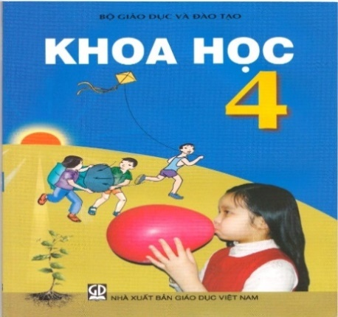

2. She is reading a \_\_\_\_\_\_\_\_\_\_\_\_ now. 

3. Today is the \_\_\_\_\_\_\_\_\_\_\_\_ of October. 

4. They are \_\_\_\_\_\_\_\_\_\_\_\_. 

|  |  |
| --- | --- |
| **PHÒNG GD& ĐT**  **TRƯỜNG TIỂU HỌC…….** | **BÀI KIỂM TRA GIỮA HỌC KÌ I**  **Môn: Tiếng Anh 4 ( Thí điểm)**  **Thời gian: 45 phút**  **(Không kể thời gian giao đề)** |

**ĐỀ 8**

***Question 1: Chọn từ khác loại***

1. A. about B. where C. how D. who

2. A. collect B. read C. do D. like

3. A. Art B. Music C. subject D. History

4. A. blue B. puppet C. purple D. red

***Question 2: Dựa vào tranh để hoàn thành các câu sau***

1. She is \_\_\_\_\_\_\_\_\_\_\_\_\_\_ a dictation. 

2. Women’s Day is in \_\_\_\_\_\_\_\_\_\_\_\_\_\_\_\_\_. 

3. I have \_\_\_\_\_\_\_\_\_\_\_\_\_\_\_\_\_\_ today. 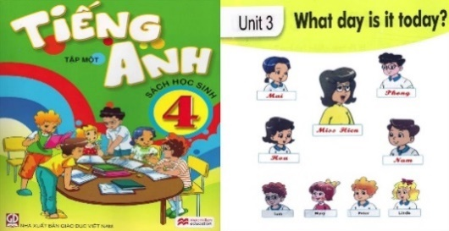

4. They \_\_\_\_\_\_\_\_\_\_\_\_\_ for a walk yesterday. 

***Question 3: Chọn từ thích hợp trong hộp thoại để điền vào chỗ trống***

|  |
| --- |
| **happy England friend dance club** |

This is my new (1) \_\_\_\_\_\_\_\_\_\_\_\_\_\_. Her name is Linda. She is from (2) \_\_\_\_\_\_\_\_\_\_\_\_\_\_. She can sing many Vietnamese songs. In her free time, she goes to music (3) \_\_\_\_\_\_\_\_\_\_\_\_\_\_. She is (4) \_\_\_\_\_\_\_\_\_\_\_\_\_\_ there.

|  |  |
| --- | --- |
| 1. | 2. |
| 3. | 4. |

***Question 4: Tìm lỗi sai trong các câu sau và sửa lại cho đúng***

1. She don’t like playing badminton. \_\_\_\_\_\_\_\_\_\_\_\_\_\_\_\_\_\_\_\_\_

2. Sandy is an pupil at Hong Bang primary school. \_\_\_\_\_\_\_\_\_\_\_\_\_\_\_\_\_\_\_\_\_

3. We have English in Friday. \_\_\_\_\_\_\_\_\_\_\_\_\_\_\_\_\_\_\_\_\_

4. My birthday is on the twenty of December. \_\_\_\_\_\_\_\_\_\_\_\_\_\_\_\_\_\_\_\_\_

***Question 5: Sắp xếp các từ sau thành câu hoàn chỉnh***

1. a/ fly/ want/ I/ to/ kite/.

\_\_\_\_\_\_\_\_\_\_\_\_\_\_\_\_\_\_\_\_\_\_\_\_\_\_\_\_\_\_\_\_\_\_\_\_\_\_\_\_\_\_\_\_\_\_\_\_\_\_\_\_

2. They/ school/ yesterday/ went/ to.

\_\_\_\_\_\_\_\_\_\_\_\_\_\_\_\_\_\_\_\_\_\_\_\_\_\_\_\_\_\_\_\_\_\_\_\_\_\_\_\_\_\_\_\_\_\_\_\_\_\_\_\_

3. When/ birthday/ your/ is/?

\_\_\_\_\_\_\_\_\_\_\_\_\_\_\_\_\_\_\_\_\_\_\_\_\_\_\_\_\_\_\_\_\_\_\_\_\_\_\_\_\_\_\_\_\_\_\_\_\_\_\_\_

4. can/ cannot/ jump high/ Tom/ but/ run fast/.

\_\_\_\_\_\_\_\_\_\_\_\_\_\_\_\_\_\_\_\_\_\_\_\_\_\_\_\_\_\_\_\_\_\_\_\_\_\_\_\_\_\_\_\_\_\_\_\_\_\_\_\_

5. Monday/ has/ on/ Tom/ PE/.

\_\_\_\_\_\_\_\_\_\_\_\_\_\_\_\_\_\_\_\_\_\_\_\_\_\_\_\_\_\_\_\_\_\_\_\_\_\_\_\_\_\_\_\_\_\_\_\_\_\_\_\_

6. doing/ What/ they/ are/?

\_\_\_\_\_\_\_\_\_\_\_\_\_\_\_\_\_\_\_\_\_\_\_\_\_\_\_\_\_\_\_\_\_\_\_\_\_\_\_\_\_\_\_\_\_\_\_\_\_\_\_\_

|  |  |
| --- | --- |
| **PHÒNG GD& ĐT**  **TRƯỜNG TIỂU HỌC…….** | **BÀI KIỂM TRA GIỮA HỌC KÌ I**  **Môn: Tiếng Anh 4 ( Thí điểm)**  **Thời gian: 45 phút**  **(Không kể thời gian giao đề)** |

**ĐỀ 9**

**Exercise 1: Choose the odd one out**

1. A. park

B. rubber

A. pen

B. notebook

2. A. run

B. go

C. play

D. water

3. A. countryside

B. teacher

C. farmer

D. doctor

**Exercise 2: Choose the word whose underlined part is pronounced differently from the rest**

1. A. flats

B. days

C. jobs

D. chairs

2. A. school

B. chair

C. children

D. chick

**Exercise 3: Choose the correct answer**

1. The boys \_\_\_\_\_\_ paper planes now

A. are doing

B. does

C. are making

D. makes

2. Yesterday morning, he \_\_\_\_\_\_\_\_\_ his friends on the Internet

A. chat with

B. chatted with

C. chat to

D. chatted to

3. \_\_\_\_\_\_\_\_\_ birthday is this today? - It’s \_\_\_\_\_\_\_\_\_\_\_.

A. Whose/ my brother

B. Whose/ my brother’s

C. Who/ my brother

D. Whom/ my brother’s

4. It’s \_\_\_\_\_\_\_\_\_ at school and the students are in the playground.

A. broken time

B. break time

C. full time

D. part time

5. They study Maths \_\_\_\_\_\_\_\_ Monday \_\_\_\_\_\_\_\_ Friday

A. from - to

B. from - on

C. on - on

D. on - to

6. I \_\_\_\_\_\_\_\_ television before I went to bed last night

A. listened to

B. watched

C. read

D. played

7. Can you \_\_\_\_\_\_\_ a bike?

A. ride

B. skate

C. skip

D. dance

8. They \_\_\_\_\_\_\_ in their room all day.

A. did

B. did be

C. was

D. weren’t

**Exercise 4: Read the following text and choose the best answer**

Here is Brandon. He goes to London Primary School. He is in class 4A. This is his classroom. There are fifteen boys and ten girls in his class. His best friend is Lucas. Thay both enjoy Geography. They have it on Thursdays and Fridays. On Saturdays and Sundays, they don’t have to go to school. They often play soccer together. Yesterday was Sunday. They played football in a playground near his house.

1. Which school does Brandon go to?

A. Brandon studies at Primary School

B. Brandon goes to Primary School

C. Brandon studies at London Primary School

D. Brandon is going to Primary School

2. How many boys and girls are in his class?

A. Fifth boys and ten girls

B. Five boys and tenth girls

C. Fifteen boys and ten girls

D. Fifty boys and ten girls

3. Who is his best friend?

A. Brandon

B. Lucas

C. Geography

D. Primary

4. Do they have to go to school on Saturdays and Sundays?

A. Not

B. No, they aren’t

C. Yes, they do

D. No, they don’t

5. Where did they play football yesterday?

A. In a playground near his house

B. In the school ground

C. In the stadium

D. Near the library

**Exercise 5: Reorder these words to have correct sentences**

1. her/ dance/ beautifully/ can/ sister/ ./

\_\_\_\_\_\_\_\_\_\_\_\_\_\_\_\_\_\_\_\_\_\_\_\_\_\_\_\_\_\_\_\_\_\_\_\_\_\_\_\_\_\_\_\_\_\_\_\_

2. school/ my/ big/ is/ a/ city/ in/ ./

\_\_\_\_\_\_\_\_\_\_\_\_\_\_\_\_\_\_\_\_\_\_\_\_\_\_\_\_\_\_\_\_\_\_\_\_\_\_\_\_\_\_\_\_\_\_\_\_

3. I/ evening/ TV/ watched/ yesterday/ ./

\_\_\_\_\_\_\_\_\_\_\_\_\_\_\_\_\_\_\_\_\_\_\_\_\_\_\_\_\_\_\_\_\_\_\_\_\_\_\_\_\_\_\_\_\_\_\_\_

4. what/ yesterday/ did/ they/ do/ ?/

\_\_\_\_\_\_\_\_\_\_\_\_\_\_\_\_\_\_\_\_\_\_\_\_\_\_\_\_\_\_\_\_\_\_\_\_\_\_\_\_\_\_\_\_\_\_\_\_

|  |  |
| --- | --- |
| **PHÒNG GD& ĐT**  **TRƯỜNG TIỂU HỌC…….** | **BÀI KIỂM TRA GIỮA HỌC KÌ I**  **Môn: Tiếng Anh 4 ( Thí điểm)**  **Thời gian: 45 phút**  **(Không kể thời gian giao đề)** |

**ĐỀ 10**

**I. Circle the odd one out.**

|  |  |  |  |
| --- | --- | --- | --- |
| 1. A. father | B. mother | C. sister | D. family |
| 2. A. may | B. its | C. your | D. my |
| 3. A. bedroom | B. house | C. bathroom | D. kitchen |
| 4. A. please | B. he | C. she | D. I |
| 5. A.how | B. who | C. on | D.what |

**II. Choose the best answer.**

1. Hi. My ............. Tom.

A. name

B. names

C. name’s

D. am

2. What’s ................. name? – His name’s Alan.

A. your

B. her

C. my

D. his

3. That is my mother. ..................Lan.

A. Her name’s

B. Name’s

C. His name’s

D. He’s

4. .................that? – That’s my brother.

A. What’s

B. What name’s

C. How’s

D. Who’s

5. Is your friend, Linda? - ............, it is.

A. Yes

B. She

C. No

D. This

6. ...................is my school. ................is big.

A. He – It

B. That- This

C. This- It

D. She- It

7. There ................. a .................on the table.

A. is – book

B. Are - book

C. is – books  
D. are – books  
8. What’s ................ name? – It’s Thang Long school. A. it’s  
B. Your  
C. its  
D. his  
9. There .............. two pens .............. the school bag. A. are – in  
B. are – on  
C. is – on  
D. is - in  
10. This is my bedroom. .............. large. A. This  
B. It’s  
C. They’re  
D. Its

Nối các câu hỏi ở cột A với các câu trả lời ở cột B (2pt)

|  |  |
| --- | --- |
| A | B |
| 1. What’s her job?  2. What time do you get up?  3. I like chicken.........  4. What time is it? | a. It’s my favourite food.  b. At six  c. It’s nine fifteen.  d. She’s a teacher |

Đọc đoạn văn sau và trả lời câu hỏi (2pt)

This is my mother. Her name is Hoa. She is a doctor. She gets up early, at 5.15 in the morning. She goes to work at six o’clock. She works in the hospital from 7.30 a.m to 4.30 p.m. She arrives home at 5 o’clock. In the afternoon, she watches TV and she goes to bed at 10.00 o’clock.

1. What is her name?

………………………………………………………………………………

2. What is her job?

………………………………………………………………………………

3. What time does she go to work?

………………………………………………………………………………

4. Does she arrive home at 4.30 p.m?

………………………………………………………………………………

|  |  |
| --- | --- |
| **PHÒNG GD& ĐT**  **TRƯỜNG TIỂU HỌC…….** | **BÀI KIỂM TRA GIỮA HỌC KÌ I**  **Môn: Tiếng Anh 4 ( Thí điểm)**  **Thời gian: 45 phút**  **(Không kể thời gian giao đề)** |

**ĐỀ 11**

**I. Odd one out:**

|  |  |  |  |
| --- | --- | --- | --- |
| 1. A. morning | B. afternoon | C. evening | D. birthday |
| 2. A. England | B. America | C. Vietnamese | D. Japan |
| 3. A. swim | B. January | C. March | D. May |
| 4. A. ride | B. badminton | C. dance | D. play |
| 5. A. Monday | B. Thursday | C. Friday | D. week |

**II. Arrange the sentences**

1. is/ Linda/ from/ Japan/ ./

……………………………………………………..

2. you/ are/ Where/ from/?

……………………………………………………

3. in/ school/ My/ is/ Tokyo/ ./

……………………………………………………

4. Nga/ your/ birthday/ When/ is/?

…………………………………………………….

5. school/where/ your/ is/ ?/

…………………………………………………….

**III. Choose the words which have different pronunciations**

|  |  |  |  |
| --- | --- | --- | --- |
| 1. red | children | Eleven | pencil |
| 2. thin | skirt | music | children |
| 3. mouse | blouse | trouser | group |
| 4. face | ant | fast | bat |
| 5. white | nineteen | thinner | triangle |
| 6. pant | math | art | ant |

**IV. Choose the correct answer.**

1.What (am/is/are) your phone number? It’s 546746453

2. How (old/age/year) is she? She’s 16 years old.

3. They are 20 years (old/young/age).

4. How old (am/is/are) they? They’re 35.

5. How (much/many) stars can you see? I can see six stars.

6. How many (circle/circles) can you see? 3 circles.

7. 30 plus 16 (am/is/are) 46.

8. (would/will) you like some chocolate? Yes, please!

9. What is (your/my/her) favorite subject? I like P.E.

10. (where/when/what) do you have Math? I have Math on Tuesday.

|  |  |
| --- | --- |
| **PHÒNG GD& ĐT**  **TRƯỜNG TIỂU HỌC…….** | **BÀI KIỂM TRA GIỮA HỌC KÌ I**  **Môn: Tiếng Anh 4 ( Thí điểm)**  **Thời gian: 45 phút**  **(Không kể thời gian giao đề)** |

**ĐỀ 12**

**PART I. LISTENING**

***Question 1: Listen and tick. (1pt)***

 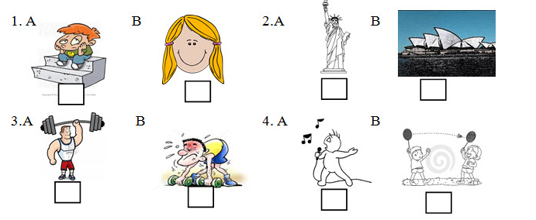

***Question 2: Listen and number. (1pt)***

|  |  |  |  |
| --- | --- | --- | --- |
| am, nhac | tieng viet | tieng anh | toan |
| A. | B. | C. | D. |

***Question 3: Listen and complete the dialogue (1pt):***

Teacher: What’s your full (1)...................?

Nam: Le Van Nam.

Teacher: When is your birthday?

Nam: It’s in (2)....................

Teacher: What class are you in?

Nam: I’m in (3)..............

Teacher: What is your favourite subject?

Nam: (4)................... and Science.

**PART II. READING AND WRITING**

***Question 4: Read and tick (1pt):***

*Example:*



|  |  |  |
| --- | --- | --- |
| 0. He’s from America. | A.  √ | B. |
| 1. She is Japanese. | Ao_dai_Beauty_by_Alexandra_chan  A. | japanese  B. |
| 2.They are benches. | benchh  A. | bench  B. |
| 3. He can’t ride a bike. | nga xe dap  A. | ride a bike  B. |
| 4.She’s slim. | slim  A. | short  B. |

***Question 5: Look at the pictures and the letters. Write the words (1pt)*:**

|  |  |
| --- | --- |
| *Example:*  0. That is a p e n. |  |
| canada  1. I’m from Au\_ \_ \_ \_ \_ \_ \_ |  |
| bóng đá2. My hobby is playing f \_ \_ \_ \_ \_ \_ \_ . | thang 12 |
| 3. My birthday is in D \_ \_ \_ \_ \_ \_ \_.  4. My favourite subject is E \_ \_ \_ \_ \_ \_. | tieng anh |

***Question 6: Match column A with column B (1pt)*:**

|  |  |  |
| --- | --- | --- |
| **A** |  | **B** |
| 0. What is it? | 0 - D | A. It’s in August. |
| 1. When’s your birthday? | 1 - | B. Tony is taller. |
| 2.What day is it today? | 2 - | C. Once a week. |
| 3. How often have you got Art? | 3 - | D. It’s a new clock. |
| 4. Who is taller? | 4 - | E. It’s Wednesday. |

***Question 7: Choose the word from the box and complete the dialogue(1pt):***

|  |
| --- |
| *today Music favourite Monday* |

Mai: What day is it (1)........................., Nam?

Nam: It’s (2)..................................

Mai: What lesson have you got today?

Nam: I’ve got Maths, Science, English and (3)........................

Mai: What is your (4).............................. subject?

Nam: Maths and Art.

***Question 8: Look and read.Write Yes or No(1pt):***

Hi. My name is Linda. This is Ha Noi International School. It is in Lieu Giai Street. This is my class room. There are two boards on the wall. There are twenty desks and twenty chairs in the classroom. That is my new classmate. Her name is Akio. She’s from Japan. She is small and slim

*Example:* 0. Linda’s school is Ha Noi International School *Yes*

1. It’s in Rose Street. \_\_\_\_\_

2.There is a board in her classroom. \_\_\_\_\_

3.There are twenty desks in her classroom. \_\_\_\_\_

4. Akio is small and short. \_\_\_\_\_

***Question 9: Reorder the words (1pt):***

0./Mai / am /I / ./

=> I am Mai.

1. / singing / is / hobby / My / . /

=>...........................................................................................................................

2. / have / How often / you / English / got / ? /

=>...........................................................................................................................

3. / is / a table / There / in / my / classroom / . /

=>...........................................................................................................................

4. **/** is / strong / He / . /

=>...........................................................................................................................

***Question 10: Look and read. Put a tick √or cross*** *X* ***in the box as examples (1 pt):***

*Examples:*

|  |  |  |  |
| --- | --- | --- | --- |
|  | 0. This is a pen. | ***√*** | |
|  | 1. This is a desk. | X | |
| weakthang 1 | 2. It’s the first of May |  | |
|  | 3. He is weak. |  | |
| cau long | 4. My hobby is playing football. | |  | |
| class | 5. There is a board on the wall. | |  | | |

|  |  |
| --- | --- |
| **PHÒNG GD& ĐT**  **TRƯỜNG TIỂU HỌC…….** | **BÀI KIỂM TRA GIỮA HỌC KÌ I**  **Môn: Tiếng Anh 4 ( Thí điểm)**  **Thời gian: 45 phút**  **(Không kể thời gian giao đề)** |

**ĐỀ 13**

**LISTENING (3ms)**

**PART 1: Nghe và khoanh tròn vào đáp án  đúng(0.5 m).** 

1. I can speak \_\_\_\_\_\_\_\_\_\_ very well.

A. Vietnamese                       B. English                                          C. Japanese

2.  What are Tom and Peter doing? – They are \_\_\_\_\_\_\_\_\_\_\_\_\_\_\_\_\_\_\_\_\_.

          A. reading                               B. playing chess                               C. playing football

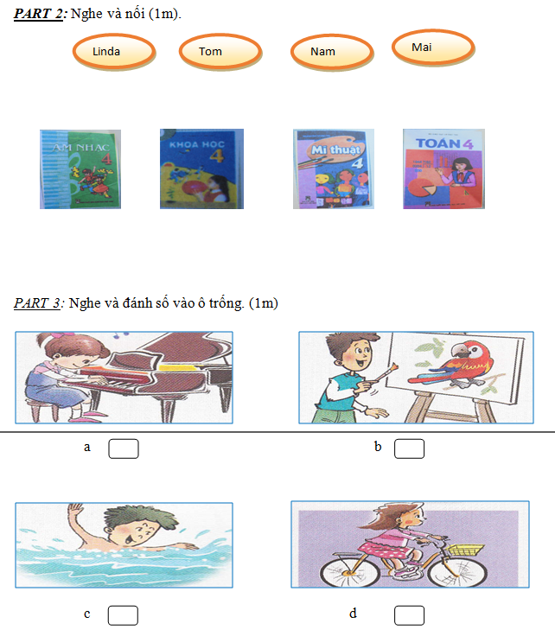



**PART 4: Nghe và hoàn thành đoạn hội thoại sau sau (0.5m)**

**Nam           : What are you reading?**

**Tom           : I’m reading a (1) \_\_\_\_\_\_\_\_\_\_\_\_\_\_\_\_\_\_\_\_\_ .**

**Nam           : Let’s play (2) \_\_\_\_\_\_\_\_\_\_\_\_\_\_\_\_,Tom.**

**Tom           : Great idea!**

**READING AND WRITING (5ms)**

**PART 1: Đọc và dánh dấu tick   vào ô Yes hoặc No (1m).**

            Hi. My name is Linda. This is Ha Noi International School. It is in Lieu Giai Street. This is my class room. There are two boards on the wall. There are twenty desks and twenty chairs in the classroom. That is my new classmate. Her name is Akio. She’s from Japan. She is small and slim                                      **Yes           No**

1. Linda’s school is Ha Noi International School

2. It’s in Rose Street.

3. There is a board in her classroom.

4. There are twenty desks in her classroom.

**PART 2: Đọc và hoàn thành đoạn văn sau: (1m)**

|  |
| --- |
| **today                Music             favourite             Monday** |

Mai     : What day is it (1)……………, Nam?

Nam    : It’s (2)………………..

Mai     : What lesson have you got today?

Nam    : I’ve got Maths, Science, English and (3)…………..

Mai     :What is your (4)……………… subject?

Nam    : Maths and Art.

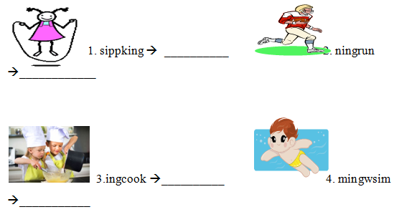

PART 4: Sắp xếp các từ đã cho theo thứ tự để tạo thành câu đúng.(1m)

1. It’s / second / of / the / October/.

=>……………………………………………………..

2. student/ at/ Primary School/ I/ a/ am/ No Trang Long/.

=>………………………………………………

|  |  |
| --- | --- |
| **PHÒNG GD& ĐT**  **TRƯỜNG TIỂU HỌC…….** | **BÀI KIỂM TRA GIỮA HỌC KÌ I**  **Môn: Tiếng Anh 4 ( Thí điểm)**  **Thời gian: 45 phút**  **(Không kể thời gian giao đề)** |

**ĐỀ 14**

**PART I. LISTENING (20 minutes)**

**Question 1**. **Listen and number. (1pt)**

 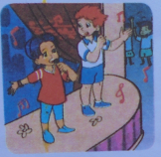  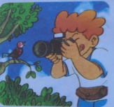

**Question 2**. **Listen and tick. (1pt)**

1.  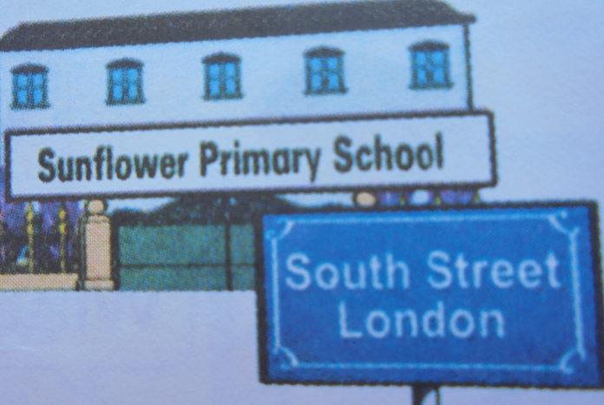 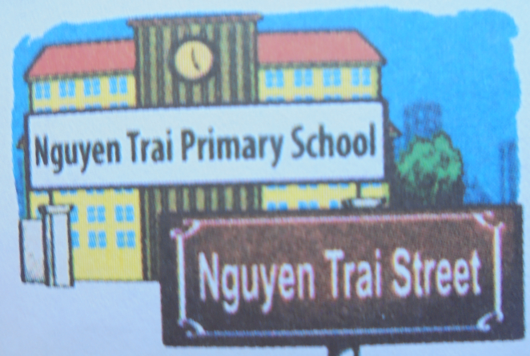

4. 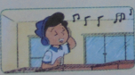 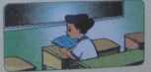 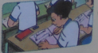

3.

|  |  |  |
| --- | --- | --- |
|  |  |  |
|  |  |  |
| 2.  **6**  **TUESDAY**  **8**  **THURSDAY**  **9**  **FRIDAY** |  |  |
| 3.3 SACH NGHE 3 QUYEN SACH 3 Q SACH  3. |  |  |
|  |  |  |

**Question 3: Listen and draw the line. (1 pt)**

|  |  |  |
| --- | --- | --- |
|  |  |  |
|  |  |  |
|  |  |  |

**Question 4:** **Listen and circle** **(1 pt)**

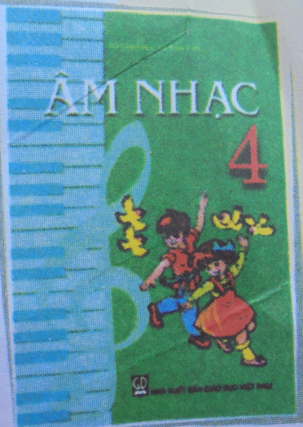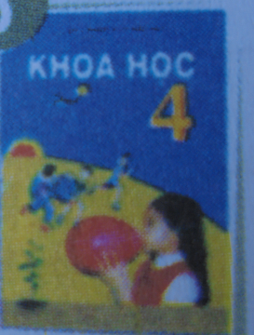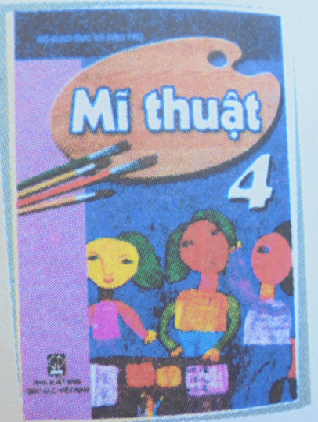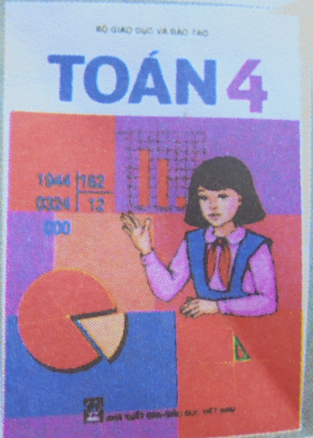

|  |  |
| --- | --- |
| 1. I like…………….  a. playing football  b. flying a kite | 2. He likes……………….  A. playing the guitar  b. playing the piano |
| 3. She likes………………  a. sailing a boat  b. playing with a yo-yo | 4. We like……………….  a. flying in a plane  b. flying a kite |

**Question 5: Listen and complete. (1pt)**

Nam : Hi,Mai.Where’s Tom?

Mai : He is (1) the classroom.

Nam : What’s he (2) ?

Mai : He’s reading .

Nam : What are you(3) ?

Tom : I’m reading a (4) .

Nam : Let’s play football,Tom.

Tom : Great idea!

**PART II: READING AND WRITING (15 minutes)**

**Question 6: Look and read. Put a tick (🗸) or a cross (x) in the box.(1pt)**

|  |  |
| --- | --- |
| 1. They’re playing badminton. | CHOI Q VOYT |
| 2. They’re in class 5B. | GAI 4A |
| 3. They’re drawing a picture. | VE TRANH |
| 4.She is riding a bike. | THA DIEU |

**Question 7: Read and write the suitable words in the gaps.(1pt)**

**Name**: Jane

**Nationality**:English

**School**: Oxford Primary school

**School address**: Oxford Street,London

**Class**: 4A



Hello. My name is (1) . I’m from London, England. I’m (2) . I study at (3) . It’s a big school in (4) . I’m in class 4A.

**Question 8: Look at pictures. Look at the letters. Write the words .(1pt)**



|  |  |  |  |
| --- | --- | --- | --- |
| 1. | sippking | 🠪 ………….... |  |
| 2. | ningrun | 🠪 ………….... | MC900332830[1] |
| 3. | ingcook | 🠪 ………….... | MM900356720[1] |
| 4 . | mingwsim | 🠪 ………….... | MC900438153[2] |

**Question 9: Fill in each gap with a suitable word from the box. (1pt)**

|  |  |  |  |  |
| --- | --- | --- | --- | --- |
| HAT NHAC  singing and dancing | CHUP ANH  taking photos | BE TRAI NGHE NHAC  listening to music | BE TRAI DOC SACH  reading books | THA DIEU  flying kites |

Hi, my name is Mai. I have a lot of friends Linda, Nam, Phong and Peter. We have different hobbies. I like singing and dancing. Nam likes ­ Linda likes . Phong likes and Peter likes .

|  |  |
| --- | --- |
| **PHÒNG GD& ĐT**  **TRƯỜNG TIỂU HỌC…….** | **BÀI KIỂM TRA GIỮA HỌC KÌ I**  **Môn: Tiếng Anh 4 ( Thí điểm)**  **Thời gian: 45 phút**  **(Không kể thời gian giao đề)** |

**ĐỀ 15**

**I. Hãy quan sát kỹ bức tranh rồi điền chữ cái chỉ bức tranh đó. (1,5 điểm)**

A. rubber B. plane C. badminton

D. cooking E. watch TV F. Maths

|  |  |  |
| --- | --- | --- |
| 1. ......... | 2. ……. | 3. … |
| 4. ……. | 5. …… | 6. …….. |

**II. Sắp xếp các chữ cái để tạo thành từ đúng. (1 điểm)**

1. gib 🡪 ..........................

2. hsrto 🡪 ..........................

3. lsim 🡪 ..........................

4. eakw 🡪 ...........................

**III. Đọc đoạn văn sau và hoàn thành các bài tập bên dưới. (2 điểm)**

It is Friday today. We are having a break. We are doing exercise in the school playground. Phong is jumping. Linda and Mai are playing badminton. Nam and Tom are skipping. Quan and Peter are playing basketball. We are having a lot of fun here.

**a)** **Tích vào câu đúng (T) hoặc sai (F). (Mỗi câu đúng được 0,25 điểm)**

|  |  |  |  |
| --- | --- | --- | --- |
|  | **T** |  | **F** |
| 1. We are doing exercise in the school gym. |  |  |  |
| 2. Phong is skipping. |  |  |  |
| 3. Linda and Peter are playing badminton. |  |  |  |
| 4. Nam and Tom are skipping. |  |  |  |
| 5. Quan and Peter are playing table tennis. |  |  |  |

**b) Trả lời câu hỏi (0,75 điểm)**

1. Where are they doing? (0,25điểm)

............................................................................................................................................

2. What are Quan and Peter doing? (0,25điểm)

............................................................................................................................................

3. Are they having a lot of fun here? (0,25điểm)

...........................................................................................................................................

**IV. Đọc và nối (2,5 điểm)**

|  |  |
| --- | --- |
| 1. Where are you from? | A. I can play volleyball. |
| 2. What day is it today? | B. I watched TV. |
| 3. What can you do? | C. I’m from Japan. |
| 4. What’s he doing? | D. It’s Wednesday. |
| 5. What did you do yesterday? | E. He’s painting a mask. |

**V. Hãy sắp xếp các từ theo đúng thứ tự để tạo thành câu có nghĩa. (2 điểm)**

1. in / 4A / I / class / am /.

🡪 ------------------------------------------------------------------

2. your / nationality / What / are /?

🡪 -----------------------------------------------------------------

3. school / I / at / yesterday / was /.

🡪 -----------------------------------------------------------------

4. What / have / you / today / subjects / do /?

🡪 -----------------------------------------------------------------

**V. Nghe và khoanh tròn vào đáp án đúng. (1 điểm)**

1. a. English b. Japanese c. Vietnamese

2. a. Monday b. Tuesday c. Sunday

3. a. Nguyen Trai Street b. Nguyen Hue Street c. Nguyen Du Street

4. a. reading b. swimming c. cooking